NAVIGATION APP FOR HAMPTON SCHOOL
(Note to self you have named the barry martin centre bazza martin centre throughout this document, perhaps change this before the final submission)

Robert Ng
U6CHR
Glossary
Contents
Inception 3
Analysis 4
Background to the Problem 4
Problems faced by End User 4
Existing Solutions 7
Client Conversation Requirements 9
Objectives 10
Low Level Objectives 10
High Level Objectives 10
Design 11
User Interface: Menu 11
Base Button Class 15
Command Button Class 15
UserOptions Button Class 16
Start Button Class 17
Back Button Class 18
DropDown Button Class 19
Window Class 20
SubWindow Class 20
MainWindow Class 21
User Interface: Graphically Displaying the Navigation 21
navUI Class 28
Window Class 29
Travel Class 30
Path Finding Algorithm: Encoding The Map (Graphing) 31
Path Finding Algorithm: Dijkstra’s Algorithm 39
Implementation/ Technical Solution 46
MainProgram.py 46
Navigation.py 52
Data.py 62
Testing 79
Evaluation 103

Inception
Aim: To produce a program or application that will choose the shortest path to get from point A to point B (or in this case room A to room B) in Hampton School.

The idea for this project was initially brought up by a teacher in class (props to Mr Ting) which after hearing I added to my options for possible NEAs. After more considerate thought, I decided that the most challenging as well as interesting problem to solve would be to use an algorithm to navigate our school taking the shortest path like google maps for a school (although hopefully taking the best path rather than the next to best from a heuristic algorithm). This hopefully will help my client (a new teacher at Hampton) as well as other new joiners to the school in navigating our vast complicated school. As such the aim is to help as many new Hampton joiners as possible with this navigation system.

Client: Mr Thompson
The client in question is a new teacher at my school who (being new) is unfamiliar with the layout of the building. It is important to him that the product is easy to use and clear in providing the solution to the user.

Analysis

Background to the Problem
To clarify:
- The problem being solved is the struggle for new joiners to Hampton school in navigating to their next lessons given how big and complicated it can be
- The solution will require finding a correct path to get to the destination from a current point as well as the fastest path
As previously stated, this program will be like Google maps in that it is a navigation system that will give you a path to get from point A to point B. However differently to Google maps’ heuristic algorithm, I hope to use Dijkstra’s algorithm to return the shortest path given that I will be dealing with fewer variables, so a heuristic algorithm is unnecessary (the difference in time to reach a solution is negligible from the users’ perspective).

Problems faced by End User
The end users of the problem will be anyone looking to navigate the school, whether new teachers and students unfamiliar with the school format, or completely new guests visiting the school for whatever reason. As of now, no clear solution exists to this problem unless the user in question has someone with them leading them who already knows the school format in depth, or a map with them. Both of these “solutions” are not particularly convenient as the former requires someone to know the school in the first place (which even for a student such as I who has been at the school for years still am unsure where some rooms of the school are, NB: below I’ve also done a test to check this fact) and the latter is rather clunky as the map is relatively small and hard to use.
To investigate the fact above, there are results below showing whether individual students know where rooms are, and how to navigate between them:

Null Hypothesis: The average student knows how to navigate the school
Alternate Hypothesis: The average student doesn’t know how to navigate the school
Where justification of a student “knowing” how to navigate would be being able to identify the rough location of a room in the school with 40% success rate. (Better written hypothesis would be p = 0.4, p < 0.4 where p is the probability a student can successfully locate a room in the school)
I will set my significance level to be 1%, hence the critical value will be 0.01
Below is the list of data obtained from surveying different students.
Student | Room 1 | Room 2 | Room 3 | Room 4 | Room 5 | Room 6
Student 1 | Fail | Fail | Pass | Fail | Fail | Fail
Student 2 | Fail | Pass | Pass | Fail | Pass | Fail
Student 3 | Fail | Fail | Fail | Fail | Fail | Fail
Student 4 | Fail | Fail | Fail | Fail | Fail | Pass
Student 5 | Fail | Pass | Fail | Fail | Fail | Fail
Student 6 | Fail | Fail | Fail | Fail | Fail | Fail
Student 7 | Pass | Fail | Fail | Pass | Fail | Fail
Student 8 | Fail | Fail | Pass | Fail | Fail | Fail
Student 9 | Fail | Pass | Fail | Fail | Fail | Fail
Student 10 | Fail | Fail | Fail | Fail | Fail | Fail
Student 11 | Fail | Pass | Fail | Fail | Fail | Pass
Student 12 | Fail | Pass | Fail | Fail | Fail | Fail
Student 13 | Fail | Fail | Fail | Fail | Fail | Fail
Student 14 | Fail | Fail | Fail | Pass | Fail | Fail
Student 15 | Fail | Fail | Fail | Fail | Fail | Fail
Student 16 | Fail | Pass | Fail | Fail | Pass | Pass
Student 17 | Pass | Fail | Fail | Fail | Fail | Pass
Student 18 | Pass | Pass | Fail | Pass | Fail | Pass
Student 19 | Fail | Fail | Fail | Fail | Fail | Fail
Student 20 | Fail | Fail | Fail | Pass | Pass | Fail
Student 21 | Fail | Pass | Pass | Fail | Fail | Fail
Student 22 | Fail | Fail | Pass | Fail | Fail | Fail
Student 23 | Pass | Pass | Fail | Fail | Fail | Pass
Student 24 | Fail | Fail | Fail | Fail | Fail | Fail
Student 25 | Fail | Fail | Fail | Fail | Fail | Fail
Student 26 | Pass | Fail | Pass | Pass | Fail | Pass
Student 27 | Fail | Fail | Fail | Fail | Pass | Fail
Student 28 | Fail | Fail | Pass | Pass | Fail | Fail
Student 29 | Fail | Fail | Fail | Fail | Fail | Fail
Student 30 | Pass | Pass | Pass | Fail | Fail | Pass
Student 31 | Fail | Fail | Fail | Fail | Pass | Fail
Student 32 | Fail | Pass | Fail | Fail | Fail | Fail
Student 33 | Pass | Pass | Pass | Pass | Pass | Pass
Student 34 | Pass | Pass | Fail | Fail | Pass | Pass
NB: The average success rate from the data showed to be roughly a 20% success rate (19.75%), but this is irrelevant to the test
By using a binomial distribution to model the data with n = 204, and p = 0.4:
P (X<=54) = 0.000036… < Critical Value
Therefore, the data suggests that there is reason to reject the null hypothesis. There is sufficient evidence to suggest that the average student does not know how to navigate the school.
Note it’s fair to say that the average student knows how to navigate to the rooms that their classes are (as they will do this every day for a year at the minimum), however considering rooms outside their classes, the average student does not know how to navigate the school or at least most of the school.

Existing Solutions
Regarding existing applications that solve a similar problem to mine is a website called “Mapped.In”. This website develops a map of your building of choice that can be navigated using its in-built path finding algorithm. The map is loaded by layering a blueprint of the building onto a geographical top-down view of the building (seems to be effectively placing the picture of a blueprint onto the building as seen on google maps). From there, you set out where rooms, entrances to rooms and other necessities are. After confirming these options, the map is made accessible to navigate via the website. An example of a finished map on the website is shown below:
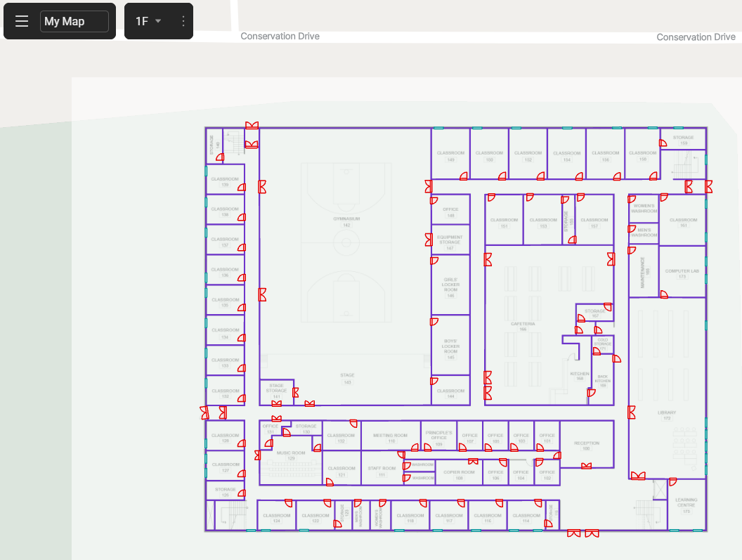
A difference and a flaw in my opinion of the website is the actual setup of the map. Their setup requires a pdf of picture form of the building’s blueprint that you may not possess and then you must place it onto the “google map” view which I found doesn’t align very well (considerably as the proportions of the building on the map are not perfect). Hence this setup was quite problematic. The aim of the website was most likely to simplify the process of mapping a building by simply putting a blueprint in, however I think this has in fact made the process more complicated and finicky. Such for my project should I develop an interface to make your own map, it will be a DIY map builder to create from scratch in contrast to the website’s method. Although simpler, this should prove to be a more functional way.
In addition, as nice is the UI for the navigation for the website is, this navigation is also then conditional having to use this website to navigate, and so dependent on network access. As such this problem is solved by navigating the map from locally stored data. (Also, usage requires a subscription which is further inconveniencing).
Another software would be the Westfield navigation app. At Westfield there are terminals placed around the shopping centre that allow you to search for a shop and it will show u the path on a top-down view of how to get there from the current terminal. Ignoring the fact that the terminals at Westfield are very clunky and unresponsive, the navigation system at Westfield is well made. The path shown is somewhat coherent and easy to understand, and additional features such as filtering by type of shop makes quality of life in usage very nice. Below is the best picture I could find showing a Westfield terminal.
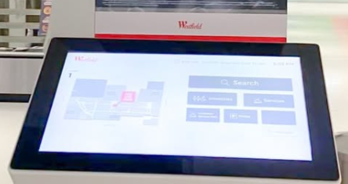
The only problem with the Westfield navigation would be its portability. The navigation system is local only to the terminals such after being shown the path, unless the user records the path using a video or memorising the full path perfectly, it’s very easy to get lost and could even get you further away from your destination. This could be solved if an application were to exist to do the Westfield navigation from a phone, however as of now this does not exist. This could just be the case at this time, or it could also be possible that the structure of their navigation system cannot be moved onto an application. Such my solution will be more portable and accessible.

Client Conversation Requirements
Below is a summarised conversation with client discussing some initial requirement they would like from the project:
Q: What situations would you mostly need this to be for?
A: Finding classrooms and school offices, particularly parts of the building that I do not frequent as often

Q: What form of referencing would you prefer to use?
A: To reference rooms (navigate between rooms)

Q: How would you like your interface to show the path?
A: A verbal description would be sufficient, however a shown path on a map would be very useful

Q: Would you like the navigation to occur autonomously without prompting between instructions, or control over each step?
A: Although being able to control navigation stepwise could be useful, I would prefer if the navigation happened automatically without my prompting, allowing me to keep my hands a little freer when moving around

Objectives
For my approach, I will be decomposing this problem into two different parts:
- The shortest path algorithm (including map coding)
- Interactive User Interface

Low Level Objectives
- Upon loading application, user presented initial menu
- This initial menu will lead to a drop-down box of start point and end point and a navigate button that should only work after both start and end points are inputted correctly
- After pressing navigate, screen should swap from initial menu to a navigation map
- UI calls onto the path finding algorithm
- Path finding algorithm finds corridor for the corresponding room within a certain floor to navigate given (Go to Design for more detail), selected from a data structure
- Interface correctly gives the verbal description of the shortest path from A to B, with descriptions passed incrementally one by one
- Map of building held as a graph

High Level Objectives
- GUI to graphically show path during navigation
- A “next” and “previous” button should be usable to move between step-by-step instructions
- “Exit” button usable to exit navigation at any point
- Navigation possible between floors
- Upon booting application, menu appears with an interface to allow you to design your own map
- Option to view an interactive map instead of navigating by algorithm (free navigation as if using map normally by yourself)
- Navigation to filter for the user type e.g. a sixth former can travel through the Barry martin centre, a lower school student cannot
Such this enables more flexibility if the existing building has changes made to it whether that’s simple room name changes or fundamental structural changes. Or even for the usage of the program to completely different buildings.
Other extended objectives include the following:
- The ability to input your timetable to auto-navigate to your next lesson based on the time
- Modelling traffic which will affect the weighting of certain paths such as
    - Dependency on time of day
    - Dependency on the frequency a path is used (i.e. more frequently used paths will have larger weighting)

Design
I have as decomposed the whole problem into the two sections of the path finding algorithm and the user interface. I will further decompose the path finding algorithm again into the algorithm itself and the graph of the map that it acts on, and the user interface into the main menu\ and the displaying of actual navigation.

User Interface: Menu
The user interface would require the following (already briefly stated above but to reiterate):
- Pre-menu to determine that will fulfil any high-level objectives if reached e.g. H5, H6
- A menu with 3 options
- Start button to start navigation
- Drop down boxes to input start point (point A)
- Drop down boxes to input end point (point B)
- A screen providing navigation of the algorithm
- Graphical visualisation (e.g. a line showing the intended path layered onto a map) (H1)
- Textual description of directions (e.g. simple and straight forward descriptors like right/ left at the end of the corridor)
- Buttons to between instructions/ steps (e.g. a next/ previous button to go intuitively to next and previous instruction) (H2)
NB: Previous button should be made unusable at start and next button unusable at end as this is logically sound that you can go back past the first instruction or past the last one.
- Button to quit navigation at any point whether at end of navigation or mid-way (H3)
The whole interface will be made using the tkinter python module.
Below is a hierarchy chart to summarize the layout of the user interface (contains some high-level objectives):
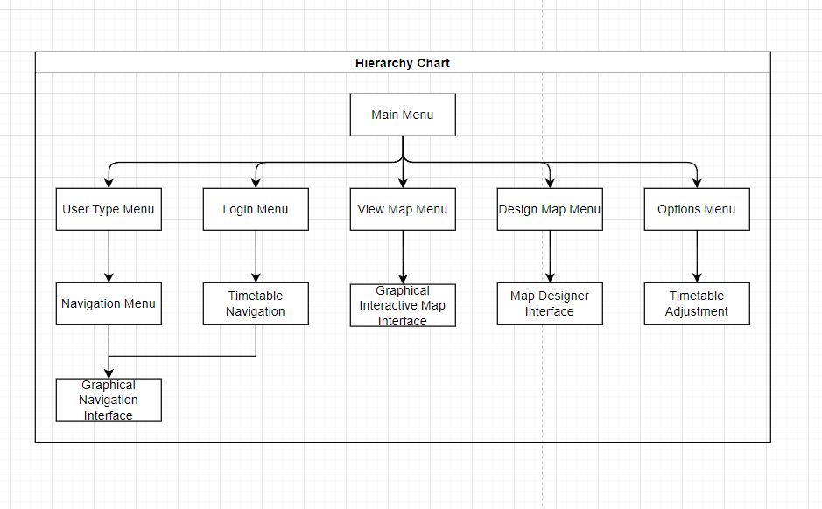
NB: Below describes just the low-level objectives for now, so doesn’t contain the UI for the map designing interface or manual map navigation
The main menu will provide the user with several options (above just shows 3 of the many options).

View Map Menu
Navigation
Login/Register
NAVIGATION APP

To align the labels and buttons in the top menu, I will align according to the central line of the window about the long axis. Such the navigation app label and navigation button are both on the central line (although at different y-coordinates) and relative to the central line the view map menu and login/register buttons are proportionally away determined by some value that can be adjusted to increase the spacing between buttons (for quality-of-life edits later). A class to produce each button will be used. Upon the press of each button, the button will prompt using methods from the class to navigate to the next menu.
4
Back
Point A
Dropdown
Point B
Dropdown
Start
On the menu for the navigation, a drop-down menu will be made from the start and end (point A and B respectively) both produced from a dedicated class. Expectedly the start button will start the step-by-step navigation in a new tkinter window after closing this menu window. The start button will check whether valid by using a method from its class.

Below shows a list of the different classes used (some are high level objectives so may not be present in the actual solution). I will now go more into depth on a few of the essential classes that will be in the solution and some that may be in the solution:
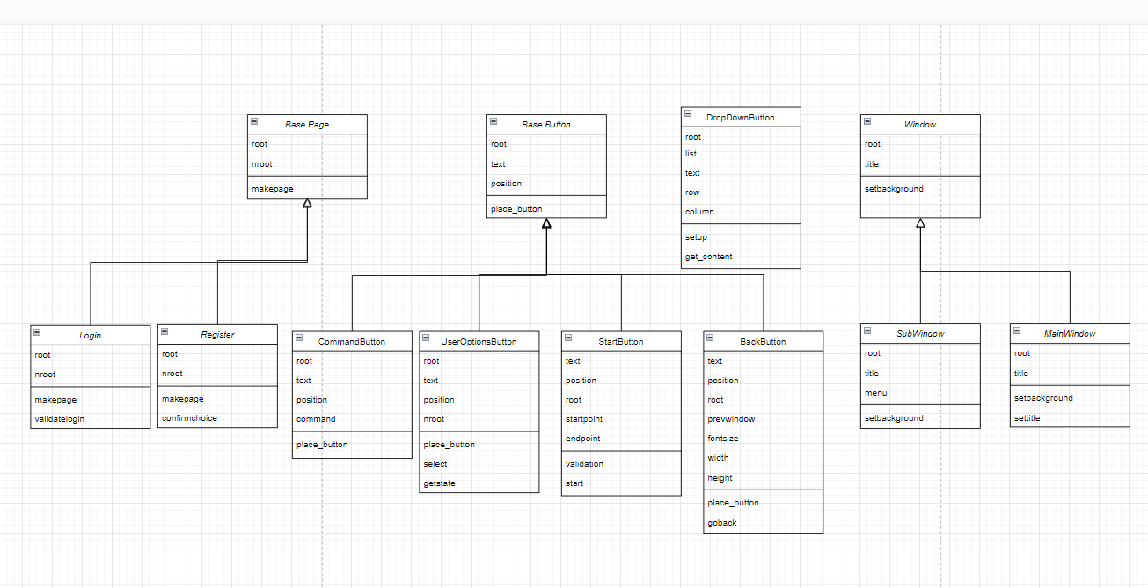

Base Button Class
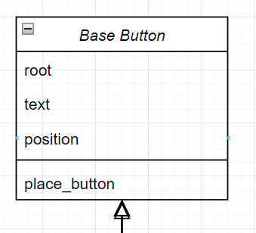
The Base Button class will be the building block class that many other buttons will inherit from. The root refers to the window and button acts on, text being the text of the button and position aiding into the placement of the button on the screen. Place_button is a self-explanatory method.

Command Button Class
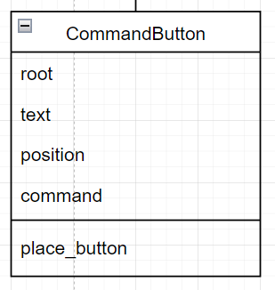
The Command Button Class inherits from the Base Button Class. This will allow the direct execution of methods that should occur immediately without an intermediate menu (such as the freeview interface on view map menu). The first three attributes are as described in Base Button. The command attribute as described is the command passed to the Button the should be executed if it is clicked.

UserOptions Button Class
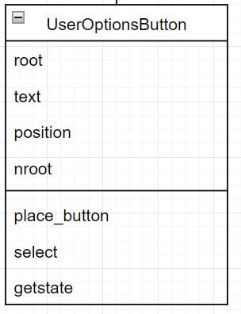
The UserOptions Button Class inherits from the Base Button Class. This class will be used to navigate between different windows and acts as the intermediary that links different windows together. The first three attributes are as described in Base Button, nroot describes the new window that the button should navigate to if clicked. The select method will be what switches the windows. Getstate will return the text of the button

Start Button Class
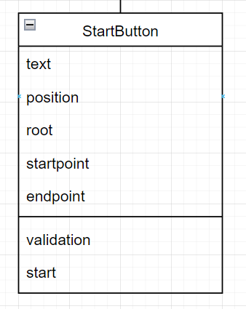
The Start Button Class inherits from the Base Button Class. This class will exclusively be used to start the autonomous navigation of the map. Again, the first three attributes are as described in the Base Button Class. The startpoint and endpoint attributes will be passed to get the selected startroom and endroom. The validation method will be used to check that the passed startroom and endroom are valid inputs. The start method will be used to start the navigation if the inputs are valid according to the validation method

Back Button Class
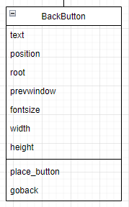
The Back Button Class inherits from the Base Button Class. This class will be used to navigate back to previous screens from a current screen. The first three attributes are as described in the Base Button Class. Prevwindow refers to the previous window that the button will navigate back to if selected. The fontsize is the fontsize of the button text, the width and height are the width and height of the button. The goback method will change the screens back to the original window.

DropDown Button Class
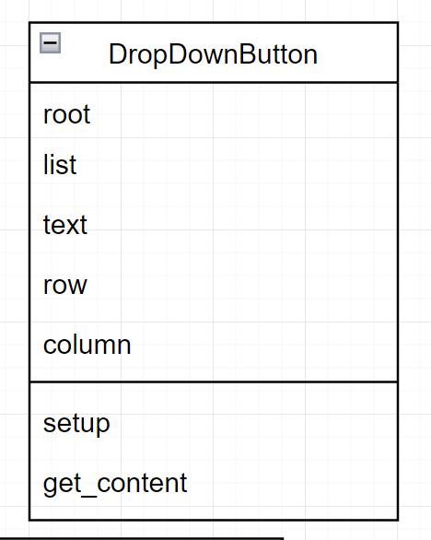
The DropDown Button Class provides the dropdown boxes to select the start and end rooms. The root refers to the screen the dropdown boxes are acting on, the list refers to the selectable options of the dropdown box, the text refers to the text of the dropdown box, the row and column refers to the position of the dropdown box. The setup method as described sets up the dropdown box in the correct position of the screen. The get_content method returns the current content of the dropdown box.

Window Class
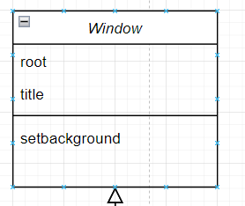
The Window Class is used to setup the windows and is the building block class for two other classes. The root refers to the window being setup and the title refers to the title of this window. The setbackground method as described sets up the background of the window.

SubWindow Class
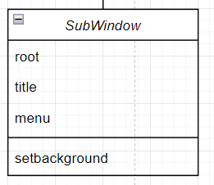
The SubWindow Class inherits from the Widow class and is used to setup all windows except the mainwindow. Instead the menu is used to setup the subwindow with the root referring to the mainwindow

MainWindow Class
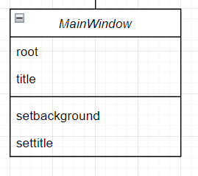
The MainWindow Class inherits from the Window class and is used exclusively to setup the main window. The settitle method sets up a title on the main window menu.

User Interface: Graphically Displaying the Navigation
Akin to the menu setup, this will also be displayed using the tkinter python module.
The graphical display of the map navigation will be carried out by displaying a line of certain colour (e.g. red) to illustrate the path to be taken across the school. Initially I thought to incorporate some form of player movement for the line to traverse the school. However, I instead decided that instead of having a player move, that I would instead move the map around the player such that the player always stays at the same point on the screen and to simulate the player moving, the map moves respectively.
To move the map, an image of the corresponding floor is loaded onto a “canvas object”. The canvas object is used to contain the image, and trail. This way if I want to simulate the movement of a player, I can move both the image and trail at the same time (as the trail is effectively being draw onto the image). This canvas is then displayed onto the window. To move the image then the whole canvas on the window is moved by a corresponding amount. To simulate the movement of a player moving, the map (canvas) is moved in the opposite direction (logically sound as the map is moving opposed to the player, then for the relative motion of the player to be one way, the map must move in the opposite direction by frame of reference).
V_{r}=5ms⁻¹
V_{g}=(-)5ms⁻¹
V_{b}=0ms⁻¹
In this scenario, from the perspective of the ground, the block is moving away at 5ms⁻¹, however from the perspective of the block the ground is moving 5ms⁻¹ away. In fact, this describes from an independent observer the ground is moving away from the block and the block is not moving, but it simulates the idea of the block moving at 5ms⁻¹. It is by this idea that I may move my map in the opposite direction to the player.
This idea is more easily understood when you’re for example on a bus, the surroundings around you are moving away as you pass them as you move forwards. So, to you who could be considered “stationary” the surroundings are all moving away.
As a result, the map coordinates will be displaced by a factor to which the screen/ canvas is placed off the screen (this is annotated later in the code).
The coordinate system in tkinter starts with the origin in the upper left (by placing a canvas at coordinates 0,0 it will place the canvas in the top left). The coordinate system then operates contrastingly as you would expect such going down the y-axis is increasing the y-value of the map coordinate and up the y-axis is decreasing the y-value (and vice versa for the x-axes). So, to move the map up, the y-value must be decreased. However, as motion of the player is required to be opposite to the motion of the map, to simulate a player moving up will simply be increasing the y-value as expected and the x-value inverted.
Initially using an existing map of my school, I put this onto the canvas and navigated appropriately. This worked perfectly fine for manual “WASD” navigation, however as eventually I would need this to navigate autonomously, this model of the map was far too complex with many small turnings (likely as intended to accurately represent the real turnings around the building). Below is an example of this:
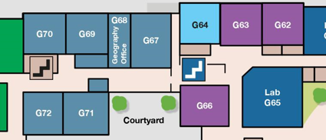

This snippet of the map shows a path that my algorithm may have to navigate down which has many turns and twists making it much more complex to graph (e.g. I would have to add many more nodes to get round these corners). Instead, I have re-designed the map abstracting any irrelevant information:
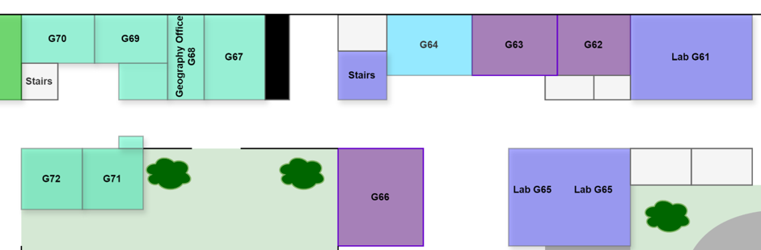
The re-designed map has removed all these turnings and turned it into a straight path across, much simple and easier to represent in code than the former.
(The actual difference in number of nodes is from 10 nodes to 5 nodes halving the number needed in this case)
These kinds of turnings appear across the original map on all floors, such re-designing the map became essential.
By redesigning the map myself, this also made graphing the map much easier (as seen later) as it made making direct changes to the map very simple.
As I have already just stated, the school contains many small turnings to accurately represent the school that makes navigation much tougher hence the need to re-design. During this redesign I also employed representational abstraction on the map. There are many parts of the map excluding the shape of corridors themselves, which although accurate, are unnecessary and could even confuse the user. The idea behind a map in this case is not to illustrate all the detailed features of the school, but to simply indicate the relative position of rooms across the school and hence make navigating it easy. Other things that I have decided to abstract include: unlabelled rooms as these are mainly just supply closets of some kind or else something that you should not be navigating too anyway, multiple entrances to certain rooms (there are certain rooms with multiple doors which is just unnecessary if the aim is to get to the room, simply getting to one of the entrances is sufficient) and just other unnecessary features of the map they put on whether that’s the trees and bushes decorated on the map or the individual parking spaces (as the target is to navigate between rooms, this kind of information is pointless in this situation). Also, although minimal and rare, the original map does miss some features of the actual building including a couple missing rooms and staircases or rooms just in the wrong place (relative to the walls).

An example of this scenario is shown below:
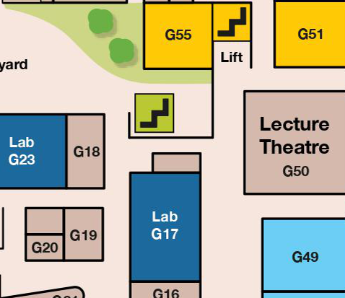
Here is a snippet of part of the original map with a focus on the marked green staircase. According to the map this staircase, it is placed relative to the marked X, outside it on the other side of a wall and from the perspective on the side of Lecture Theatre, on the right. In fact, this placement is completely wrong (I am not sure as to how or why, but it most certainly is). The green staircase is really inside the building and from the perspective of the Lecture theatre on the left.

Below shows my re-designed map correctly depicting this idea:
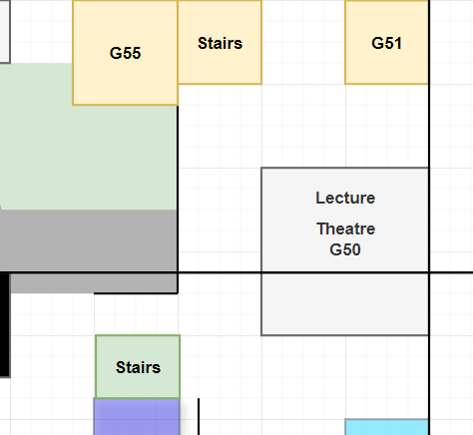
Now the stair is correctly placed on the other side of the marked X point, and inside the building. (In addition, it can be seen where the unlabelled room circled in green, which is a supply closet, has been removed as this is unnecessary information to the user).
The class diagram layout used for the navigation display is show below:
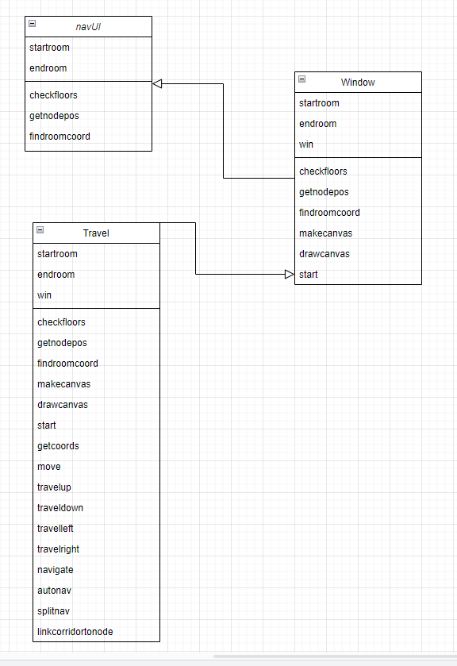
Then with each explained in further detail:

navUI Class
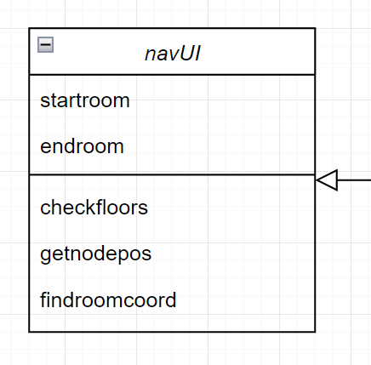
The navUI class is used as the parent class to help construct the other two classes in this part of the program. Startroom and endroom are as described. The checkfloors method checks to see what floors are involved in the navigation. The getnodepos method gets the coordinates of a room which is between two nodes. The findroomcoord method as described finds the placement of room within a corridor (explained in more depth in the implementation) and works in tandem with the getnodepos to return the room coordinates.

Window Class
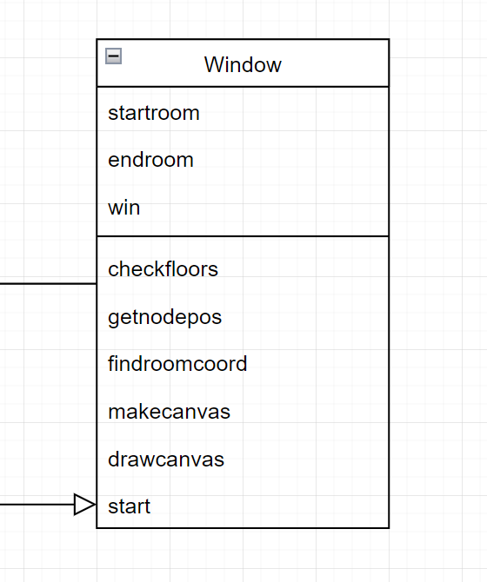
The Window Class inherits from the navUI class. The win attribute refers to the window that is being used. The makecanvas method initialises the canvas that is used to move the map and draw the trail. The drawcanvas method is used to load the map for a corresponding floor onto the canvas. The start method starts the navigation screen.

Travel Class
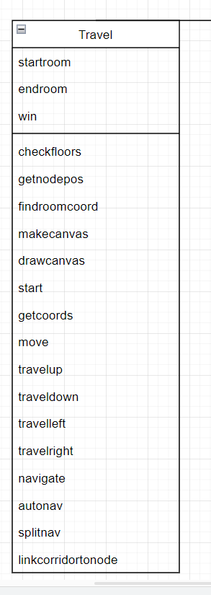
The Travel Class inherits from the Window Class the getcoords method as described gets the current coordinates of the canvas. The move method moves the canvas by a certain amount and produces the trail for the user to see. The travel”” methods each travel in their respective directions using recursive calls until a node is reached, to which it will stop. The navigate method sets up all the data structures such that it can be animated by autonav for a specific floor (explained better in the implementation). The autonav method is used to perform the automatic navigation and determines in which direction to travel based on the given path. The splitnav method splits up the given path into separate paths to be navigated on each floor. The linkcorridortonode function is used to obtain the two nodes that connect a corridor. Called by the splitnav method

Path Finding Algorithm: Encoding The Map (Graphing)
At first, for simplicity I will hardcode my map into the program (and should it happen later the interface to draw your own map). To help visualise this problem I took the existing map of Hampton and using draw.io I copied it onto this. A section of this is shown below. 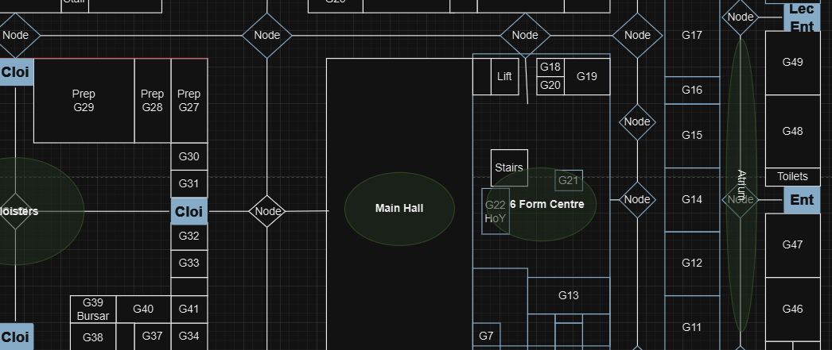

As can be seen, I initially placed nodes at each point where the corridor spits to another path. Prior to this I considered making every room a node and navigating to them (like the simple model of the A-to-Z graph), however I quickly realized that this was much too complex and inefficient considering the number of nodes this would result in the path finding algorithm looking through. Hence why I initially place nodes at each corridor intersection. This however was still had the problem of how my program would go from a node to the rooms themselves within each corridor.
I then considered the nodes to be the corridors themselves. The same section with corridors can be seen below: 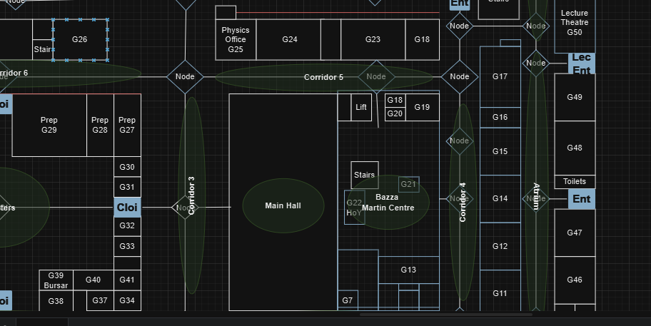
This solution solved the previous problem of being unable to navigate to rooms within a corridor. This way I could associate all rooms to their relevant corridors, and so to navigate to a specific room first search for which corridor this would be, and from there navigate to said corridor. The only downfall to this method was this would require searching for which corridor a room is within, this can be optimised later, and this solution also makes the graph much simpler to create, edit and correct if needed. This solution also will reduce the number of coordinates needed to be stored in my data structure (as will only need to store node coordinates rather than every room coordinates). This does however mean that for the graphical representation of the navigation. I considered then re-using the path finding algorithm within corridors to navigate to the exact room within one, however a much easier solution I found was to prefix each corridor within its data structure with a value from 0-9. This would allocate the approximate position within its corridor, relative to the length of the corridor.

An example is shown below displaying this idea:
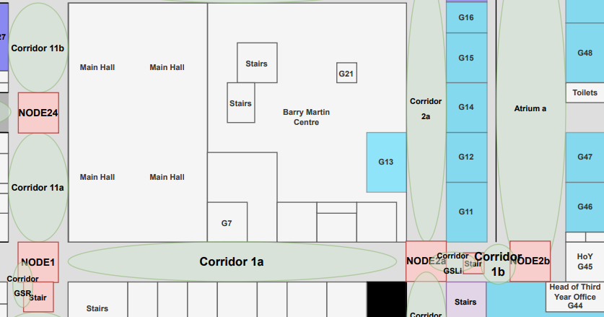
This re-designed version of the school map shows the nodes and corridors placed around the map at certain key points for the navigation. If we take Corridor 2a for example, this is connected to the two nodes Node 2a and Node 3a (the latter node cannot be seen but it’s just above). Starting from the bottom to the top, room G11 would be stored as 0G11 to indicate that the G11 is at the bottom of the corridor. G12 and G13 would be stored as 3G12/13 as these rooms are roughly 3 parts the way along. Hence this way I can approximately represent the position of every room in the school. The system that a 0 or where I start each corridor from is the same as x-y cartesian format (right and up are positive, left and down are negative). Such each corridor starts from the left or bottom.
One problem with this form location tracking would be how to split a corridor into 10 different parts (for 0-9 locations) as if I take the same example of corridor 2a, the length of this corridor from node to node will likely be a value that is not 10 or a multiple of 10, hence I cannot simply allocate a coordinate to each location straight away.
To split each corridor into its constituent parts of ten, I will be using set of mathematical expressions which I have decided on that will give the most even spread of spacing across.

Consider the below example:
1 | 2 | 3 | 4 | 5 | 6 | 7 | 8 | 9 | 10 | 11 | 12 | 13 | 14
Say this is my corridor of length 14 that I want to split into 10 locations, hence assigning a location to a coordinate in a way that spaces each of the 10 locations somewhat equally apart (or in the most equally spaced manner possible).
As I want to split my corridor into 10 spaces, I will divide the corridor length by 10 and consider the quotient and remainder. Hence for this example:
Corridor Length = 14
Corridor Length / 10 = 1 remainder 4
I will reference the quotient now as the jump (will make more sense during explanation).
This calculation explained literally describes that the corridor length if split into 10 parts, we can assign 1 value to each of the 10 parts (the quotient) and be left with 4 values remaining unassigned. Below shows this representation:
1 | 2 | 3 | 4 | 5 | 6 | 7 | 8 | 9 | 10

1 | 2 | 3 | 4
So, we need to assign the 4 values equally across the 10 parts. To do this divide 10 by the number of values left (the remainder from the original expression) and consider only the quotient. This is otherwise floor division (done in python as //). In this case:
Remainder = 4
10 // 4 = 2
This value (2) indicates roughly how often I should place a value from the remainder across the 10 values such they are somewhat equally spaced (Note that as the remainder is 4, after 4 values have been allocated, should stop allocating any more values). Below shows this operation:
0 | 1 | 2 | 3 | 4 | 5 | 6 | 7 | 8 | 9
 | 1 |  | 1 |  | 1 |  | 1
Hence as seen each of the 4 values from the remainder is somewhat equally spaced across the 10 values (with a spacing of 2 at the end however this would always exist no matter the arrangement, such where this double spacing occurs is irrelevant for my case). Such if I add each value as such below stepwise:
0 | 2 + 1 = 3 | 4 | 5 + 1 = 6 | 7 | 8 + 1 = 9 | 10 | 11 + 1 = 12 | 13 | 14

1 | 3 | 4 | 6 | 7 | 9 | 10 | 12 | 13 | 14
I have now split the length 14 corridor into 10 parts that are somewhat equally spaced across the corridor. So, position 0 (the first value as lists start counting from 0 in python) will correspond to 1 unit along the corridor. Position 1 will correspond to 3 units along the corridor. Vice versa with the following values ending with position 9 being 14 units along the corridor or at the end of the corridor.
It's important to note that it was convenient in this scenario that the quotient or jump was 1 as makes it easy to comprehend visually, but with a larger jump say if the corridor length were instead 34 such the jump is 3, then instead the operation would look as follows:
3 | 6 | 9 | 12 | 15 | 18 | 21 | 24 | 27 | 30
 | 1 |  | 1 |  | 1 |  | 1

3 | 6 + 1 = 7 | 10 | 13 + 1 = 14 | 17 | 20 + 1 = 21 | 24 | 27 + 1 = 28 | 31 | 34

3 | 7 | 10 | 14 | 17 | 21 | 24 | 28 | 31 | 34

Such as shown the jump depicts the jump between each value ignoring the addition remainder. This process can be simplified to an expression that each value in the list as
(jump x position) + displacement_value
Where position start counting from 1 and up to 10 and the displacement_value describes the displacement in the list caused by the remainder, such at the start this value is zero, and each time a remainder value is added, the displacement_value is incremented by one.
Below shows a draft of the tabling of rooms that fall into each corresponding corridor. A table for the first floor is shown below as an example of how this would look:
Corridor Type | Contents
Reception | Main Entrance, Headmaster’s Office, G2, Reception Stairs
Corridor 1 | G3-G10
Corridor 2 | G35-G40, Cloisters, Cloisters Entrance, G91A-G91B, Med Room (Nurse)
Corridor 3 | G30-G34, G41, Main Hall
Corridor 4 | G11-G17, Barry Martin Centre, Language Stairs, Library Stairs
Barry Martin Centre | G21-G22, Barry Martin Stairs
Corridor 5 | G18-G20, G23-G25
Corridor 6 | G26-G29, Cloister Toilets, “Orange” Stairs (as per the map)
Atrium | G42-G49, Lecture Theatre Entrance (check map as may be unclear to what entrance this is)
Corridor 7 | G50-G54, History Toilet
Corridor 8 | G55-G58, Courtyard Entrance, G61-G64, Chemistry Staircase
Corridor CS | G65-G66
Corridor 9 | “Blue” Stairs (as per the map), G79, G67-G72, Art Stairs, Courtyard Entrance
Corridor 10 | G73-G78, English Stairs
Corridor 11 | Hammond Theatre, Hammond Staff Toilets, G81, Changing Room for North Gym
Corridor 12 | Dining Hall (students), Lower School Queue
Corridor Hammond 1 | G85-G86, Toilet (performance changing rooms)
Corridor Hammond 2 | Dance Studio/ Drama Stairs, G87-G89
Corridor 13 | Staff Dining Hall Stairs, Main School Queue
Corridor 14 | P1-P9
Corridor 15 | P10-P11, Practise Rooms, Garrik Staff Toilets

From this, when hardcoding the map each corridor will be put into a database that stores the contents of the corresponding rooms, so if you wanted to navigate to G21, the program would know to navigate to the Barry Martin Centre by selecting the corridor tab from the G21 record of the database. An example of part of a table of contents for the above is partially shown below (I can’t show the whole table as its unpractically long of size 282 rows for all the rooms of just the ground floor):
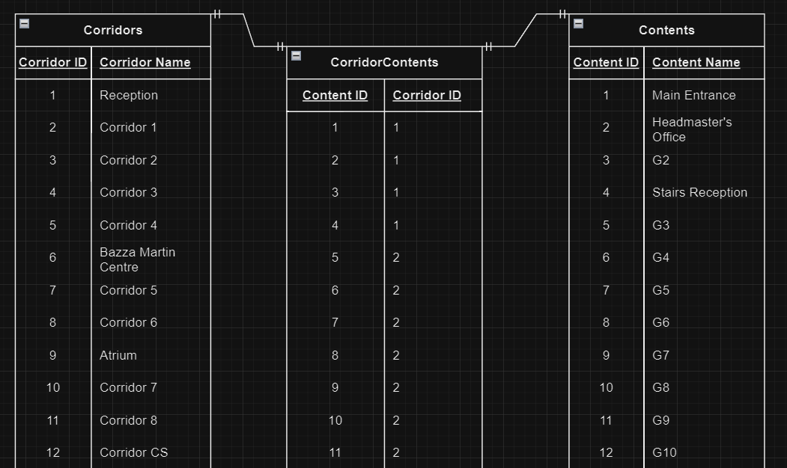
The above format is made to be compatible with a 3rd normalised form database, but the data will likely be stored as a different form of combination of data structures as there’s no justification to use a database over simpler lists and dictionaries. And, as its data that will never change whether adding or deleting (unless school goes through a remodelling which is unlikely) then that’s even less reason to use a database. Then to further expand this table (for higher-level objectives) I can add attributes that add functionality to the program such as a “level access” attribute under the contents (and potentially the corridor) tables. The “level access” attribute will range between the values 1-3, with 1 being a lower school student, 2 being a sixth form student, and 3 being a teacher. As such if a user wants to navigate to a certain room, it will return a solution that the user can take according to their level of access (for example a sixth form student can go through the Barry martin centre, but a lower school student cannot). Hence if the user’s level of access is greater than or equal to the required “level access” then it can take the path. In addition, I will add coordinates for each node (note this is just to model how the high-level objective H5 will be achieved if this point is reached)

Path Finding Algorithm: Dijkstra’s Algorithm
The algorithm I will be using as stated previously will be Dijkstra’s shortest path algorithm. I had previously considered other heuristic algorithms such as the A* algorithm, however I decided that this would not only make the project drastically more complicated as I would have to produce some sort of heuristic function that then requires more data on its relative position to the final goal (that said this idea is included in a high-level objective H7 should I get there). In addition, using this algorithm would not prove to be particularly beneficial or significant for the user as the difference in time to obtain the shortest path will be in the magnitude of 10^-3 seconds, so to the user negligible (also there could be a chance that the A* algorithm returns a solution that is not the shortest path).
The following steps would typically be used to code this algorithm:
- Create a set of all unvisited nodes: the unvisited set
- Assign to every node a distance from start value: for the starting node, it is zero, and for all other nodes, it is infinity, since initially no path is known to these nodes. During execution, the distance of a node N is the length of the shortest path discovered so far between the start node and N.
- From the unvisited set, select the current node to be the one with the smallest distance; initially, this is the starting node (distance zero). If the unvisited set is empty or contains only nodes with infinite distance (which are unreachable), then the algorithm terminates by skipping to step 6. If the only concern is the path to the target node, the algorithm terminates once the current node is the target node. Otherwise, the algorithm continues.
- For the current node, consider all of it is unvisited neighbours and update their distances through the current node; compare the newly calculated distance to the one current assigned to the neighbour and assign the smaller one to it. For example, if the current node A is marked with 6, and the edge connecting it with its neighbour B has length 2, then the distance to B from A is 6 + 2 = 8. If B was previously marked with a distance greater than 8 (the original path to B through A is longer), then update it to 8. Otherwise, if B was previously marked with a distance less than 8 (the original path to B through is A is shorter), keep it at its current distance.
- After considering all the current node’s unvisited neighbours, the current node is removed from the unvisited set. Thus, a visited node is never rechecked, which is correct because the distances recorded on the current node is minimal, and thus final. Repeat from step 3.
- Once the loop exits (steps 3-5), every visited node contains its shortest distance from the starting node.
Then again, the above but instead in pseudocode:
function Dijkstra(Graph, source):
dist[source] := 0 // Distance from source to source is set to 0
for each vertex v in Graph: // Initializations
if v ≠ source
dist[v] := infinity // Unknown distance function from source to each node set to infinity
add v to Q // All nodes initially in Q

while Q is not empty: // The main loop
v := vertex in Q with min dist[v] // In the first run-through, this vertex is the source node
remove v from Q

for each neighbor u of v: // where neighbor u has not yet been removed from Q.
alt := dist[v] + length(v, u)
if alt < dist[u]: // A shorter path to u has been found
dist[u] := alt // Update distance of u

return dist[]
end function

I will then adapt the above algorithm to be run recursively instead of using a while loop. The pseudocode for a recursive Dijkstra’s shortest path algorithm is shown below:
function Dijkstra(Graph, source, dist = {}, prev = {}, Q = null):
// Initialize on the first call
if Q is null:
Q = set()
for each vertex v in Graph.Vertices:
dist[v] = INFINITY
prev[v] = UNDEFINED
Q.add(v)
dist[source] = 0

// Base case: Stop when all nodes are visited
if Q is empty:
return dist, prev

// Pick the unvisited node with the smallest distance
u = vertex in Q with min dist[u]
Q.remove(u)

// Update distances to neighbors
for each neighbor v of u in Q:
alt = dist[u] + Graph.Edges(u, v)
if alt < dist[v]:
dist[v] = alt
prev[v] = u

// Recursive call
return Dijkstra(Graph, source, dist, prev, Q)
The time complexity of the Dijkstra’s algorithm that I am using is O(n²) and the space complexity is O(n).
Note that the time complexity can be improved if implemented using a priority queue, akin to the reasoning as to why I have not used an A* algorithm but instead Dijkstra’s algorithm, the difference in time to solution with respect to the user is negligible.
Below is a walkthrough through an example graph using Dijkstra’s algorithm.
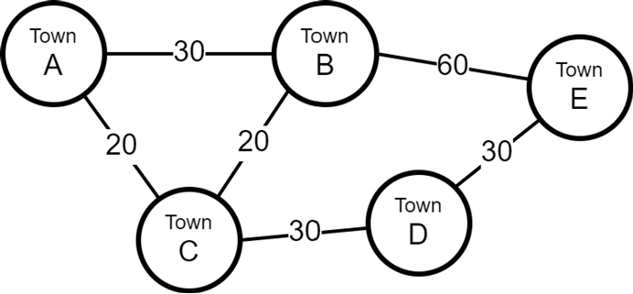
By manually working out every path, below shows the distance for each root from A to E (note for this example we are taking A as the start node and E as the end node).
Possible routes | Distances | Total distance
A to B to E | 30+60 | 90
A to B to C to D to E | 30+20+30+30 | 120
A to C to B to E | 20+20+60 | 100
A to C to D to E | 20+30+30 | 80

So, walking through the algorithm each data structure is initialised:
Node | A | B | C | D | E
Distance | 0 | inf | inf | inf | Inf
Unvisited |  | X | X | X | X
As starting from Node A, mark node A as visited (so remove from the unvisited set) and every distance from A to the other nodes as infinity (as distance to them is currently unknown) and set Node A as the current node.
Check each node connected to the current node and check its distance from the start node. So, in this case set distance from the start node to B and C as 20 and 30 respectively:
Node | A | B | C | D | E
Distance | 0 | 30 | 20 | inf | Inf
Unvisited |  | X | X | X | X

The unvisited set is not empty (so some nodes have not been visited) so look for closest node from the current node (that is in the unvisited set). In this case, node C is the closest node so set the current node as node C. As a result, we now mark node C as visited (so remove from the unvisited set) and repeat the process of checking distances to each node:
Node | A | B | C | D | E
Distance | 0 | 30 | 20 | 20+30 =50 | Inf
Unvisited |  | X |  | X | X
Note a couple important parts on this step:
- We check node B from node C, which is distance 20 away, so by going through C the distance from B to the start is 20 (the distance from node C to the start) + 20 (the distance from node B to C). As this distance is not less than the current distance from node B to the start (30) then do nothing.
- A similar process when checking node D, we set the distance from node D to the start as the sum of the distance from current node to node D and distance from current node to start (so 30 + 20 = 50)

Then from current node, set the new current node as the next closest neighbouring node that is in the unvisited set. In this case this is node B:
Node | A | B | C | D | E
Distance | 0 | 30 | 20 | 50 | Inf
Unvisited |  |  |  | X | X
Then checking the distance from current node to neighbouring node, and if the total distance to the start from these neighbouring nodes is less than the current distance to start node (from the Distances set) then set that distance as the new distance from the start:
Node | A | B | C | D | E
Distance | 0 | 30 | 20 | 50 | 30+60=90
Unvisited |  |  |  | X | X
Now once again repeat for the next closest node to the current node so in this case node E:
Node | A | B | C | D | E
Distance | 0 | 30 | 20 | 50 | 90
Unvisited |  |  |  | X
No changes to distances from node E, so continue to node D:
Node | A | B | C | D | E
Distance | 0 | 30 | 20 | 50 | 90
Unvisited
Now that the unvisited set is empty, we know that every node has been visited, such we have found the shortest distance as 90 to go from node A to node E.
Note this explanation was quite simplified and misses some concepts, however it was simply to show a stepwise process of Dijkstra’s shortest path finding algorithm. The prior pseudocodes are more accurate to what I will employ in my code.

Implementation/ Technical Solution
The below code will describe the basic solution, that the low-level objectives and some high-level objectives

FreeViewNavigation.py
# Import the required libraries
from tkinter import * #Used to run GUI
from PIL import Image, ImageTk #Used to load Images

class window(): #Class to run all code
def __init__(self,win,file):
self.file = file #the desired to be floor
self.win = win #the window the map will appear on
self.winwidth = 400 #initialising the window width
self.winheight = 800 #initialising the window height
self.win.geometry(f"{self.winwidth}x{self.winheight}") #initialising the window size

self.imagesizex = 4200 #initialising the image size
self.imagesizey = 3138
self.adjust_x = (self.winwidth)/2 #the adjustment to place the user in the centre of the screen
self.adjust_y = (self.winheight)/2

self.makecanvas()

def makecanvas(self):
startcoordtempx = -2068-self.adjust_x # the values 2068 and 1608 just depict the chosen start coordinates
startcoordtempy = -1608-self.adjust_y
x_coord = (startcoordtempx)+int(self.winwidth)/2 #the coordinates that the canvas and so image will be placed
y_coord = (startcoordtempy)+int(self.winheight)/2
self.canvas = Canvas(self.win, width=self.imagesizex, height=self.imagesizey, bg="black") #setting up the canvas
self.canvas.place(x=x_coord,y=y_coord) #placing the canvas
self.canvas.bind("<ButtonPress-1>", self.scroll_start) #setting up the freeview scrolling option to the mouse
self.canvas.bind("<B1-Motion>", self.scroll_move)
self.drawcanvas(self.file)

def drawcanvas(self,file): #pass image as the file name
self.canvas.delete("all") #clear the canvas
#selecting the corresponding file image
if file == "Ground Floor":
file = ('HamptonMapMyVerGroundFloor.drawio.png')
elif file == "First Floor":
file = ('HamptonMapMyVerFirstFloor.drawio.png')
elif file == "Second Floor":
file = ('HamptonMapMyVerSecondFloor.drawio.png')

self.image = ImageTk.PhotoImage(Image.open(file)) #load the image
self.canvas.create_image(0,0,anchor=NW,image=self.image) #create the image onto the canvas
self.win.update() #update the screen

'''Following two functions are used to move the canvas freely using the mouse'''
def scroll_start(self,event):
self.canvas.scan_mark(event.x, event.y)
def scroll_move(self,event):
self.canvas.scan_dragto(event.x, event.y, gain=1)

def start(self): #start the window
self.win.mainloop()

def startground():
win = Toplevel() #setup the window
travel_interface = window(win,"Ground Floor") #initialise the interface
travel_interface.start() #start the program

def startfirst():
win = Toplevel() #setup the window
travel_interface = window(win,"First Floor") #initialise the interface
travel_interface.start() #start the program

def startsecond():
win = Toplevel() #setup the window
travel_interface = window(win,"Second Floor") #initialise the interface
travel_interface.start() #start the program

NEA Menu.py
import tkinter as tk
from tkinter import ttk,messagebox
import Data
import MainProgram
import Navigation
import FreeViewNavigation

CorridorContent = Data.CorridorContent
rooms = [room[1:] for key in CorridorContent for room in CorridorContent[key]]

###MAKING FUNCTIONS AND CLASSES###
class Window():
def __init__(self,root,title):
self.root = root #the screen/window being used
self.title = title #title of the screen/window
self.root.title(self.title) #setting up the screen/window name
self.width = "1200" #defining the screen/window width
self.height = "550" #defining the screen/window height
self.root.geometry(f"{self.width}x{self.height}") #setting up the screen/window size

def setbackground(self,window):
self.frame = tk.Frame(window,background="light grey") #control the background colour
self.frame.place(relwidth=1,relheight=1) #Place the frame (background) onto the screen

class MainWindow(Window):#inherit from the Window Class, this class is exclusively for the main starting window
def __init__(self, root, title):
super().__init__(root, title)
self.setbackground(self.root) #set up background on the screen/window
self.settitle()

def settitle(self): #sets up the title of the screen/window using a label
title_label = ttk.Label(self.root,text=self.title,font=("Comic Sans MS",50,"bold"),borderwidth=5,relief="solid",foreground="red") #intialising the title label
title_label.place(relx=0.5,rely=0.05,anchor="n") #placing the title label

class SubWindow(Window): #inherit from the Window class, used to produce every other window other than the main starting window
def __init__(self, root, title,menu):
super().__init__(root,title)
self.menu = menu #screen/window that is now being enacted on, root now refers to the original window
self.menu.title(title) #title of the screen/window\
self.menu.geometry(f"{self.width}x{self.height}")
self.setbackground(self.menu) #setting up the screen/window size

class BaseButton():
def __init__(self,text,position,root):
self.spacing = 0.25 #spacing that determines space between buttons for quality of life changes
self.root = root # screen/window the button will be placed on
self.text = text # text of button
self.position = position #position of button

def place_button(self):
self.button.place(anchor="n",relx=(0.5+((self.position-1)*self.spacing)),rely=0.4) #placing button on screen with relevant position

class CommandButton(BaseButton): #inherit from BaseButton, this class will be used to directly execute functions from a menu if an intermediate menu is not required
def __init__(self, text, position, root,command):
super().__init__(text, position, root)
self.button = tk.Button(self.root,text=self.text,height=4,width=15,foreground="white",background="light blue",font=("Arial",14),command=command)
self.place_button()

class UserOptionButtons(BaseButton):#inherit from BaseButton, this class will be the building block to navigate beteen screens/windows
def __init__(self, text, position,root,nroot):
super().__init__(text, position,root)
self.nroot = nroot #the newwindow that the button will navigate to
self.button = tk.Button(root,text=self.text,height=4,width=15,foreground="white",background="light blue",font=("Arial",14),command=self.select) #setup button
self.place_button() #run button placing procedure

def select(self):
self.root.withdraw() #remove the original screen/window
self.nroot.deiconify() #show the new screen/window

def getstate(self):
return self.text

class StartButton(BaseButton):#inherit from BaseButton, used exclusively to start the navigation
def __init__(self, text, position, root,startpoint,endpoint):
super().__init__(text, position, root)
self.startpoint = startpoint #dropdownbox contatining the startpoint room
self.endpoint = endpoint #dropdownbox contatining the endpoint room
self.button = tk.Button(root,text=self.text,height=4,width=15,foreground="white",background="light blue",font=("Arial",14),command=self.validation) #setup button
self.place_button() #run button placing procedure

def validation(self): #checking if the rooms are valid to be navigated
self.startroom = self.startpoint.get_content() #Get the startpoint room choice
self.endroom = self.endpoint.get_content() #Get the endpoint room choice
info = [] #initialise info list, to hold information about rooms
try:
mapper = list(Data.CorridorContent.items()) #convert Corridor content dictionary into a list
info.append(MainProgram.findroomtocorridor(self.startroom,mapper)) #adding room information
info.append(MainProgram.findroomtocorridor(self.endroom,mapper))
except IndexError: #If the no inputs are given then index error will occur, so we know inputs are just invalid
messagebox.showerror("Python Error","Invalid Inputs") #raise an error messagebox if inputs are not valid
if info[0][1] == info[1][1]: #if corridor of rooms are the same
messagebox.showerror("Python Error","Rooms in same corridor") #raises an error message box
elif (self.startroom != self.endroom) and ((self.startroom != "Select a point") and (self.endroom != "Select a point")): #If the startroom and endroom are not the same
# and are actually rooms (not the default option)
self.start() #If so start procedure
else:
messagebox.showerror("Python Error","Invalid Inputs") #raise an error messagebox if inputs are not valid

def start(self):
return Navigation.start(self.startroom,self.endroom) #Start navigation code

class BackButton(BaseButton):#inherit from BaseButton, exclusive back button for navigating between screens/windows
def __init__(self, text, position, root, prevwindow,fontsize,width,height):# position inherited from BaseButton but not necessary here
#root is the current screen/window
#prevwindow is the previous screen/window that will go back to
#the following: fontsize,width,height are self-explanatory
super().__init__(text, position, root)
self.prevwindow = prevwindow #setup previous window
self.button = tk.Button(root,text=self.text,height=height,width=width,foreground="white",background="light blue",font=("Arial",fontsize),command=self.goback) #setup button
self.place_button() #run button placing procedure

def place_button(self):
self.button.place(anchor="se",relx=1,rely=1) #placing the button in the bottom right

def goback(self): #procedure to swap screens/windows
self.root.withdraw() #minimise current screen/window
self.prevwindow.deiconify() #show previous screen/window

class DropDown():
def __init__(self,root,list,text,row,column):
self.root = root #screen/window that dropdown box will act on
self.list = list #the content of the dropdown box
self.text = text #the variable being selected (in this case it will be the rooms)
self.row = row #the row the dropdown box should be (relevance explained better in the setup procedure)
self.column = column #the column the dropdown box should be (relevance explained better in the setup procedure)
self.setup() #run dropdown box setup procedure

def setup(self):
self.dropdownbox = ttk.Combobox(self.root,values=self.list,width=16,font=("Arial",15),foreground="dark blue") #setting up actualy dropdown box
self.dropdownbox.set("Select a point") #Set the default option/prompt
self.label = ttk.Label(self.root,text=(f'Select a {self.text}:'),font=("Arial",15,"bold")) #setup a label for the dropdown box to desribe what is being selected
self.label.grid(row=self.row,column=self.column) #place the label in a "grid" format
self.dropdownbox.grid(row=self.row+1,column=self.column) #place the dropdown box in a "grid" format

def get_content(self):
return self.dropdownbox.get() #get the selection from the dropdown box

'''MAIN WINDOW'''
root = tk.Tk() #intialise main screen/window
win = MainWindow(root, "Navigation App") #Create the main window display

'''NAVIGATION MENU'''
navmenu = tk.Toplevel(root) #intialise screen/window for choosing rooms
menufornav = SubWindow(root,"NavMenu",navmenu) #Create subwindow for navmenu
UserOptionButtons("Navigation",1.5,root,navmenu) #Create a button on the mainwindow for navigating to the navmenu
frameNav = tk.Frame(navmenu,bg="light grey") #Create a frame on the navmenu
frameNav.pack(anchor="nw",padx=5,pady=5) #place frame on navmenu
StartPoint = DropDown(frameNav,rooms,"Start Point",0,0) #Create dropdownbox for startpoint
EndPoint = DropDown(frameNav,rooms,"End Point",0,1) #Create dropdownbox for endpoint
StartButton("Start",1.5,navmenu,StartPoint,EndPoint) #Create startbutton to start the navigation process
BackButton("Back",0,navmenu,root,14,15,4) #Back button to go back to main screen/window from navmenu

'''FREEVIEW MENU'''
freeviewmenu = tk.Toplevel(root) #intialise screen/window for choosing floor to do the freeviewnavigation
menuforfreeview = SubWindow(root,"Freeview",freeviewmenu) #Create subwindow for freeviewmenu
freeviewnavground = FreeViewNavigation.startground #Setup method to call the freeviewnavigation code for ground floor
freeviewnavfirst = FreeViewNavigation.startfirst #Setup method to call the freeviewnavigation code for first floor
freeviewnavsecond = FreeViewNavigation.startsecond #Setup method to call the freeviewnavigation code for second floor
UserOptionButtons("FreeViewMenu",0.5,root,freeviewmenu) #Create a button on the mainwindow for navigating to the freeviewmenu
Ground = CommandButton("Ground Floor",0,freeviewmenu,freeviewnavground) #Bind this above method to the freeviewmenu for ground floor navigation
First = CommandButton("First Floor",1,freeviewmenu,freeviewnavfirst) #Bind this above method to the freeviewmenu for first floor navigation
Second = CommandButton("Second Floor",2,freeviewmenu,freeviewnavsecond) #Bind this above method to the freeviewmenu for second floor navigation
BackButton("Back",0,freeviewmenu,root,14,15,4) #Back button to go back to main screen/window from navmenu

#Minimises all windows except the mainwindow
freeviewmenu.withdraw()
navmenu.withdraw()

root.mainloop() #start screen

MainProgram.py
#Importing the required libraries
import Data #Data on school graph to be enacted upon by algorithm
from functools import reduce #higher order function to shorten what would be much longer for loops into one line (line 57)
#I wont explain the purpose of any of the below as they already explained in the Data.py file so go there for explanation
CorridorContent = Data.CorridorContent
CorridorDists = Data.CorridorDists
NodeConnections = Data.NodeConnections
NodeCoords = Data.NodeCoords
CorridorFloorMapper = Data.CorridorFloorMapper

def extract_minval(list): #Function to extract the minimum value from a list (used on line 27)
min_val_index = 0 #initialise the mininumu value index variable
for current_node in range(1, len(list)): #loop through every item in the list
if list[current_node][0] < list[min_val_index][0]: #If the distance for term i in queue is less than the current minimum distance to term min index
min_val_index = current_node #set new min_index to current_node
return list.pop(min_val_index) #return the item of lowest value form the list

def dijkstra_recursive(graph, start, end, visited=None, distances=None, queue=None, predecessors=None):
if visited is None: #At the start when first running such this runs once
visited = set() #created the visited set
distances = {node: float('inf') for node in graph} #create dicitonary of nodes with each distance to the staart node as infinity
distances[start] = 0 #set distance from start node to start node as 0 (obvisouly)
queue = [(0, start)] # (distance, node) #the start node is added to the queue
predecessors = {} #predecessor list to track the path being taken
if not queue: #is the queue is empty so done
return distances, reconstruct_path(predecessors, start, end) # Return distances and path

current_distance, current_node = extract_minval(queue) #take node from queue with the current lowest distance to the node were currently at at set this to be the new current node were currently looking at

if current_node in visited: #if current node is already visited
return dijkstra_recursive(graph, start, end, visited, distances, queue, predecessors)#continue recrusivly to the next node (as no need to do the below checks then)

visited.add(current_node) #mark current node as visited

for neighbor, weight in graph[current_node].items(): #convert dictionary into a list of key value pairs using .items and loop through the neighbour nodes to the current node and its weighting
if neighbor not in visited: #if nodes isnt visited
new_distance = current_distance + weight #calculate a new distance to that node (from start node)
if new_distance < distances[neighbor]: #if the new distances is lower than the current lowest distance to the neighbour (from start node)
distances[neighbor] = new_distance #set new distance to be the lowest distance to neighbour (from start nodw)
predecessors[neighbor] = current_node #set the current node as the closest node to the neighbour node
queue.append((new_distance, neighbor))#add the new distance and neighbour to the queue

return dijkstra_recursive(graph, start, end, visited, distances, queue, predecessors)#continue recrusivly to the next node

def reconstruct_path(predecessors, start, end): #function to obtain the path of the result from dijkstras algorithm
#predecessors contains the shortest link between nodes on the path
#appears on line 26
path = [] #initialise the path
current = end #start from the end node
while current in predecessors: #while current node is in predecessors
path.append(current) #add current node to the path
current = predecessors[current] #set current node to the shortest next neighbouring node on the path
path.append(start) #once current node is no long ein predecessors then the start node has been reached, so add start node to path
return path[::-1] # Reverse the path as path was obtained in reverse order

def total_path_dist(distances,path):#function to return the total distance of the path, appears on line 117
return reduce(lambda x,y: x+y,[distances[corridor] for corridor in path]) #go through each item in the list and add them together, returning the result
#list looks through each corridor in the path and adds the distance of it to the list

def stripper(currentcorridor,currentroom,mapper): #removes the unecessary information from rooms to be more easily referenced (cleaning data)
#mapper is corridor contents turned into a list under .items(),
# in such format [Corridor1,[room1,room2,...]],[Corridor2,[room1,room2,...]],... etc.
# appears on line 91
char = mapper[currentcorridor][1][currentroom] #takes the room from list in questions
char_ = "" #intialise the character variable
for x in char: #for each character in the room
if x != ",": #if the character isnt a comma
char_ += x #add the character to the character variable
elif x == ",": #if the characteer is comma
break #break or stop the for loop there
return char_ #hence returns the room up until a comma is reached

def linkcorridortonode(corridor): #self explanatory but returns the link between each corridor and its two connection nodes (as each corridor has a node either side)
#appears on line 92
nodes = [] #initialise the nodes list
for node in NodeConnections: #for each node that exists
for neighbournode in NodeConnections[node]: #for each neighbouring node to that current node
if NodeConnections[node][neighbournode] == corridor: #if the link (corridor) between these two nodes is the corridor of interest
nodes.append(node) #add the current node to the nodes list
nodes.append(neighbournode) #add the neighbouring node to the nodes list
if len(nodes) == 2: #if the length of the nodes list is 2, then as any corridor can only have 2 node connections, then we know we are done
break #so stop the for loop
return nodes #return the nodes list

def findroomtocorridor(roomwhere,mapper):#function to find what corridor a room lies within
currentcorridor = 0 #initialise the current corridor index
currentroom = 0 #initialise the current room index
while True: #and indefinte while loop, but will break at some point no matter what through a return
try:
roomsearch=stripper(currentcorridor,currentroom,mapper)[1:] #using the stripper function, set the current room up
if roomwhere == roomsearch: #if the current room is the room of interest
return [roomwhere,mapper[currentcorridor][0],linkcorridortonode(mapper[currentcorridor][0]),mapper[currentcorridor][1][currentroom],findfloor(mapper[currentcorridor][0])]
# return the current room (which is the room of interest)
# the corridor that the room lies in,
# the nodes this corridor is connected to,
# the room with the prefixing spacing id (explained in Data.py under CorridorContent)
# the floor that this corridor lies on
elif (currentcorridor == len(mapper)-1)and(currentroom==len(mapper[currentcorridor][1])-1): #if the current corridor index is the last corridor in list
# and the current room index is equal to the number of rooms of the last corridor
print("room not in map") #the room cannot be in the map
return None #return nothing
elif (len(mapper[currentcorridor][1])==0)or(currentroom == len(mapper[currentcorridor][1])-1): #if the number of rooms in a corridor is 0,
#or the current room index is the final room in the corridor
currentcorridor += 1 #increment the corridor index by one
currentroom = 0 #reset the current room index
else:
currentroom += 1 #otherwise increment the current room index
except IndexError: #should an index error occur then repeat the code from lines 95-102
if (currentcorridor == len(mapper)-1)and(currentroom==len(mapper[currentcorridor][1])-1):
print("room not in map")
return None
elif (currentroom == len(mapper[currentcorridor][1])-1)or(len(mapper[currentcorridor][1])==0):
currentcorridor += 1
currentroom = 0

def min_dist(info,graph): #function to obtain the mininum distance path from a start node to end node
#info is a list containing all relevant info necessary of the start and end rooms
#graph is the graph that the dijkstras algorithm acts on
lowest_dist = float('inf') #initialise the lowest distance (must be inf or smth large such the next distance will always be less)
distsandpath = {} #initialise the distances and path dictionary, to map each path and its distance
for node_1 in info[0][2]: #for each node the start corridor or room is connected to
for node_2 in info[1][2]: #for each node end corridor or room is connected to
distance,path = dijkstra_recursive(graph,node_1,node_2) #find distance and path from dijkstras algorithm between the two nodes
distsandpath[f"{node_1}:{node_2}"] = [(total_path_dist(distance,path)+CorridorDists[info[0][1]]+CorridorDists[info[1][1]]),path]
#add the corresponding distance and path tothe distsandpath dictionary
#as a result a dictionary of all possible paths from start room to end room are obtained
#as each room is connected to two nodes, then between the start and end room there are 2 start and 2 end nodes
#so a totla of 4 possible paths can be taken, hence a dictioanry is used to map each path and its total path distance
for path in distsandpath: #for each path in distandpath
if distsandpath[path][0] < lowest_dist: #if the distance of the path is less than the lowest distance,
lowest_dist = distsandpath[path][0] #then set this as the new lowest distance

return [(path,distsandpath[path]) for path in distsandpath if distsandpath[path][0]==lowest_dist]
#return a pair of path and the path distance if the path is the lowest distance path
#Basically this filters to get the lowest distance path

def decodepathofnodestocorridors(path,start,end): #A function to onvert the node path into a path of corridors
Cpath = [start] #add the start corridor to the corridor path
for node in range(len(path)-1): #loop through each node in path
Cpath.append(NodeConnections[path[node]][path[node+1]]) #add to corridor path the corridor connecting the current node and next ndoe
Cpath.append(end) #add the end corridor to the corridor path
return Cpath #return the corridor path

def findfloor(corridor): #function to find the floor that a corridor lies within
for floor in CorridorFloorMapper: #for each floor in floor mapping list
for current_corridor in CorridorFloorMapper[floor]: #for each corridor in corridor mapping list of a certain floor
if corridor == current_corridor: #if the current corridor is the corridor of interest
return floor #return the floor that the corridor is on

def maincode(startroom,endroom): #the maincode that starts the pathfinding algorithm, room1 is start room, room2 is end room
mapper =list(CorridorContent.items())
info = [] #room, corridor, node, room with spacing id , floor (the order that values are stored into info)
floor = [] #initialise the floor list
info.append(findroomtocorridor(startroom,mapper)) #add relevant information of the starting room to info list
info.append(findroomtocorridor(endroom,mapper)) ##add relevant information of the ending room to info list
for item in info: #for each item in info (only 2, one for start room and one for end room)
floor.append(item[4])#add the floor that they lie on into the floor list
if info[0][1] == info[1][1]: #if the corridor of the start room and corridor of end room are the same
print("In same corridor") #then no need to navigate as they are in same corridor

else:
graph = {node:{neighbour_node:CorridorDists[NodeConnections[node][neighbour_node]] for neighbour_node in NodeConnections[node]} for node in NodeConnections}
#A list comprehension that converts the NodeConnections' corridors into distances, such it can be operated on by dijkstras algorithm
mindist = min_dist(info,graph)#find the minimum distance path from the start room to end room
return (mindist[0][1][1],decodepathofnodestocorridors(mindist[0][1][1],info[0][1],info[1][1]),info[0][2],info[1][2],info[0][3],info[1][3],floor)
#return the path of nodes, path of corridors,
# the startroom, the endroom, (both without prefixing)
# the startroom, the endroom, (both with prefixing)
# the floor list (the floors involved in navigation)

Navigation.py
# Importing the required libraries
from tkinter import * #Used to run GUI
from PIL import Image, ImageTk #Used to load images into GUI
import MainProgram #Used to perform shortest path algorithm

class navUI():
def __init__(self,startroom,endroom):
#Won't both explaining some of the below as theyre explained in Data.py
self.NodeConnections = MainProgram.NodeConnections
self.CorridorFloorMapper = MainProgram.CorridorFloorMapper
self.NodeCoords = MainProgram.NodeCoords
self.Nodes,self.Corridors,startnodepair,endnodepair,startroomplace,endroomplace,self.floors = MainProgram.maincode(startroom,endroom)
#each nodecoordmapper produces a dictionary mapping each node to its coordinates for each individual floor
self.nodecoordmapperground = {self.NodeCoords["Ground Floor"][node]:node for node in self.NodeCoords["Ground Floor"]}
self.nodecoordmapperfirst = {self.NodeCoords["First Floor"][node]:node for node in self.NodeCoords["First Floor"]}
self.nodecoordmappersecond = {self.NodeCoords["Second Floor"][node]:node for node in self.NodeCoords["Second Floor"]}
self.startroomplace = self.getnodepos(self.floors[0],startroomplace,startnodepair) #returns the coordinates of the start room
self.endroomplace = self.getnodepos(self.floors[-1],endroomplace,endnodepair) #returns the coordinates of the end room
self.linkfloors = self.checkfloors() #sets the linkfloors list to the result of the checkfloors function (below),
#linkfloors stores any corridors involved in linking floors together in navigations

def checkfloors(self,linkfloors = []): #checks what floors are involved in the navigation e.g. ground to first or first to second or both (so ground to second)
for corridor in self.Corridors: #for each corridor in the corridors involved in the path
if corridor in self.CorridorFloorMapper["Ground-First Floor"]: #if the corridor is in the ground-first floor section,
linkfloors.append([corridor,"Ground-First"]) #recongise that ground and first floors are involved, and note which corridor is causing this
elif corridor in self.CorridorFloorMapper["First-Second Floor"]: #if the corridor is in the first-second floor section,
linkfloors.append([corridor,"First-Second"]) #recongise that first and second floors are involved, and note which corridor is causing this
if len(linkfloors) == 2: #if the length of the list linkfloors is 2, i.e. both Ground-First and First-Ground connectors are involved then all 3 floors must be involved
self.floors = ["Ground Floor","First Floor","Second Floor"] #so set the floors list to contain all 3 floors
return linkfloors #return the linkfloors list, if empty then all navigation occurs on one floor

def getnodepos(self,floor,roomplace,nodepair): #function to obtain the coordinates of a room with respect to their node pairs (for the start and end node pairs)
nodepair = (self.NodeCoords[floor][nodepair[0]],self.NodeCoords[floor][nodepair[1]]) #convert the node pair to their coordinates
nodediff = (abs(nodepair[1][0] - nodepair[0][0]),abs(nodepair[1][1] - nodepair[0][1])) #find the magnitudinal difference between the x,y coordinates of the pair values
nodesections = int(nodediff[1]/7) if nodediff[0] == 0 else int(nodediff[0]/7) #split this difference into sections of length 7 (the amount the navigation animates at)
return self.findroomcoord(nodediff,nodepair,roomplace[0],nodesections) #return the above data to a function that will calculate the room coordinates between its node pairs

def findroomcoord(self,nodediff,nodepair,changescale,sections,displacement = 0): #using maths to work out the position of a room in a corridor
#I won't comment this all as it's too complex to explain each individual lines purpose without being extremely messy
#But this process is all described in the Design process of the document under Design/Path Finding Algorithm:Encoding the Map (Graphing)
sections = int(sections)
remainder = sections % 10
try:
addcoord = 10 // remainder
except ZeroDivisionError: #if remainder is zero, then except a zero division error and just consider addcord as 0
addcoord = 0
jump = sections // 10
scalefactors = []
for pos in range(1,11):
try:
if (pos % addcoord) == 0:
if displacement < remainder:
displacement += 1
except ZeroDivisionError:
pass
scalefactors.append(jump*pos + displacement)
if nodediff[0] == 0: #if no change in x
return (nodepair[0][0] , min(nodepair[0][1],nodepair[1][1]) + (scalefactors[int(changescale)])*7 ) #then change y, min() applied to select the bottom most node
elif nodediff[1] == 0: #if no change in y
return (max(nodepair[0][0],nodepair[1][0]) - (scalefactors[int(changescale)])*7 , nodepair[0][1] ) #then change x, max() applied to select the left most node

class window(navUI):#inherits from navUI
def __init__(self, startroom, endroom,win):
super().__init__(startroom, endroom)
self.win = win #the screen/window of interest
self.winwidth = 400 # the screen/window height
self.winheight = 800 # the screen/window width
self.win.geometry(f"{self.winwidth}x{self.winheight}") # the screen/window size

self.imagesizex = 4200 # the image x-dimension (width)
self.imagesizey = 3138 # the image y-dimension (height)
self.adjust_x = (self.winwidth)/2 # the adjustment in x-dimension to centre the image with the screen
self.adjust_y = (self.winheight)/2 # the adjustment in y-dimension to centre the image with the screen

self.center_box_size = 3 #the size of the centre box (the user that appears on the screen and shows where you are)
self.size = self.center_box_size + 4 #the amount the box moves with each movement
self.makecanvas() #run canvas making procedure

def makecanvas(self):
startcoordtempx = -2068-self.adjust_x # the values 2068 and 1608 just depict the start coordinates
startcoordtempy = -1608-self.adjust_y
x_coord = (startcoordtempx)+int(self.winwidth)/2 # the start coordinates of the image with accounting with the dimension adjustments of the screensize
y_coord = (startcoordtempy)+int(self.winheight)/2
self.canvas = Canvas(self.win, width=self.imagesizex, height=self.imagesizey, bg="black") #initialising the cavnvas that the map and trail act on
self.canvas.place(x=x_coord,y=y_coord) #place the canvas

def drawcanvas(self,file): #pass image as the file name
self.canvas.delete("all") #remove all object on canvas (wipe it clean)
self.image = ImageTk.PhotoImage(Image.open(file))#load the relevant image
self.canvas.create_image(0,0,anchor=NW,image=self.image)#place the image onto the canvas
self.win.update() #update screen/window

def start(self):
self.win.mainloop() #start navigation screen

class Travel(window):#inherits from the Window class, the main class responsible for actual animation of the navigation on the GUI
def __init__(self, startroom, endroom, win):
super().__init__(startroom, endroom, win)
self.count = 0 #used as a boolean flag to determine whether the map is in motion between nodes
image_test = PhotoImage(width=1,height=1) #load a square box (to act as the user)
testbtn1 = Label(self.win,image=image_test,width=self.center_box_size,height=self.center_box_size,bg="black") #intialise a black box as the user
testbtn1.place(x=(int(self.winwidth)/2),y=(int(self.winheight)/2)) #place the user in the centre of the screen/window
self.splitnav() #start splitnav function

def getcoords(self,e): #function that returns the current coordinates
print(f"coordinates: ({self.canvas.winfo_x()},{self.canvas.winfo_y()})")

def move(self,dx,dy): #function to move the user (or actually the canvas but thats explained further in the Design of the document) dx,dy are either 0,1,-1
dx = self.size * dx #set change in x as the produce of the movement constant (self.size) and the desired change in x
dy = self.size * dy #set change in y as the produce of the movement constant (self.size) and the desired change in y
newx = self.canvas.winfo_x() + dx #work out new coordinates of canvas
newy = self.canvas.winfo_y() + dy
self.canvas.place(x=newx,y=newy) #place the new canvas
self.canvas.create_rectangle((-newx+self.adjust_x),(-newy+self.adjust_y),(-newx+self.adjust_x)+self.size,(-newy+self.adjust_y)+self.size,fill="red",width=0)
#create a rectangle at the previous position, such creating a trail of the path taken

# as the next few function are almost identical, I will only comment travelup in detail and the following are self explanatory from such
def travelup(self,dx=0,dy=1): #function to travel up until a node is reached, the significance of dx,dy are also exaplained in the document in detail so won't explain here
nodecoordmapper = self.nodecoordmapper #setup the node coordinate mapping list
x = self.canvas.winfo_x() # get current canvas coordinates
y = self.canvas.winfo_y()
if (x,y) not in nodecoordmapper: #if the coordinates are not a node
self.count = 1 #set the count to 1 (set to be in motion)
self.move(dx,dy) #move the canvas according to dx,dy
self.win.after(1,self.travelup) #recursively call the travelup function
elif (x,y) in nodecoordmapper and self.count == 0: #if current coordinates are a node but the count is zero (i.e. we havent started moving yet)
self.count = 1 #set the count to 1 (set to be in motion)
self.move(dx,dy) #move the canvas according to dx,dy
self.win.after(1,self.travelup) #recursively call the travelup function
elif (x,y) in nodecoordmapper and self.count != 0: #if the current coordinates are a node and count isnt zero (i.e. we are in motion)
self.count = 0 #then set the count to be zero so we are not in motion and dont recursivly call any more

def traveldown(self,dx=0,dy=-1):
nodecoordmapper = self.nodecoordmapper
x = self.canvas.winfo_x()
y = self.canvas.winfo_y()
if (x,y) not in nodecoordmapper:
self.count = 1
self.move(dx,dy)
self.win.after(1,self.traveldown)
elif (x,y) in nodecoordmapper and self.count == 0:
self.count = 1
self.move(dx,dy)
self.win.after(1,self.traveldown)
elif (x,y) in nodecoordmapper and self.count != 0:
self.count = 0

def travelleft(self,dx=1,dy=0):
nodecoordmapper = self.nodecoordmapper
x = self.canvas.winfo_x()
y = self.canvas.winfo_y()
if (x,y) not in nodecoordmapper:
self.count = 1
self.move(dx,dy)
self.win.after(1,self.travelleft)
elif (x,y) in nodecoordmapper and self.count == 0:
self.count = 1
self.move(dx,dy)
self.win.after(1,self.travelleft)
elif (x,y) in nodecoordmapper and self.count != 0:
self.count = 0

def travelright(self,dx=-1,dy=0):
nodecoordmapper = self.nodecoordmapper
x = self.canvas.winfo_x()
y = self.canvas.winfo_y()
if (x,y) not in nodecoordmapper:
self.count = 1
self.move(dx,dy)
self.win.after(1,self.travelright)
elif (x,y) in nodecoordmapper and self.count == 0:
self.count = 1
self.move(dx,dy)
self.win.after(1,self.travelright)
elif (x,y) in nodecoordmapper and self.count != 0:
self.count = 0

def navigate(self,floor,path,startroomplace,endroomplace): #function to start the navigation for a certain floor, passing the floor, path and start and end room coordinates
if floor == "Ground Floor": #if the floor of interest is the ground floor
self.nodecoordmapper = self.nodecoordmapperground #set the node to coordinate mapping list to be for the ground floor
self.drawcanvas('HamptonMapMyVerGroundFloor.drawio.png') #load the ground floor map to the canvas
elif floor == "First Floor": #same as above but for first floor
self.nodecoordmapper = self.nodecoordmapperfirst
self.drawcanvas('HamptonMapMyVerFirstFloor.drawio.png')
elif floor == "Second Floor": #same as above but for second floor
self.nodecoordmapper = self.nodecoordmappersecond
self.drawcanvas('HamptonMapMyVerSecondFloor.drawio.png')

CoordPath = [self.NodeCoords[floor][node]for node in path] #convert the path of nodes into coordinates

if startroomplace == self.startroomplace: #if the start room is on the floor being navigated
CoordPath.insert(0,startroomplace) #add start room coordinates to the from coordinate path list
self.nodecoordmapper[startroomplace] = "StartTempNode" #add the start room coordinates to the node coordinate mapping list
if endroomplace == self.endroomplace: #the same idea for the endnode instead
CoordPath.append(self.endroomplace) #the end room coordiantes added to end of the coordinate path list
self.nodecoordmapper[self.endroomplace] = "EndTempNode"
self.canvas.place(x=CoordPath[0][0],y=CoordPath[0][1]) #place the canvas at the start node of the path
self.win.update() #update the screen/window
self.win.after(500) #wait 5 seconds before starting the navigation
self.lastchoice = "" #initialise the last navigation choice made (for the verbal descriptive process)
position = 0 #initialist the position that navigation is in along the CoordPath to be 0
while (self.canvas.winfo_x(),self.canvas.winfo_y()) != (CoordPath[-1]): #while the current coordinates are not the final coordinates in the list
choice,current_x,current_y = self.autonav(CoordPath,position) #run the autonav function (returns values which are used for different higher level objective)
position += 1 #increment the position by 1

def autonav(self,CoordPath,position):#Function to perform the auto navigation
current_x = CoordPath[position][0] #set current x as the node coordinate according to the position in navigation
current_y = CoordPath[position][1] #set current y as the node coordinate according to the position in navigation
next_x = CoordPath[position+1][0] #set next x as the node coordinate for the next position in navigation
next_y = CoordPath[position+1][1] #set next y as the node coordinate for the next position in navigation
if next_y > current_y: #if next y coordinate is greater than the current y
if self.lastchoice == "up": #if the lastchoice in the navigation was to go up,
print("Continue down corridor") #then still going up so continue down corridor
else:
print("Go up corridor") #otherwise print instruction to go up corridor
self.travelup() #call the travelup function
self.win.update() #update the screen/window
self.lastchoice = "up" #set the lastchoice in the navigation as up
self.win.after(75) #wait 0.75 seconds (delay to make the navigation easier to understand on GUI)
#the below is the same code but for each other direction so won't bother commenting again
if next_y < current_y:
if self.lastchoice == "down":
print("Continue down corridor")
else:
print("travel down")
self.traveldown()
self.win.update()
self.lastchoice = "down"
self.win.after(75)
if next_x > current_x:
if self.lastchoice == "left":
print("Continue down corridor")
else:
print("travel left")
self.travelleft()
self.win.update()
self.lastchoice = "left"
self.win.after(75)
if next_x < current_x:
if self.lastchoice == "right":
print("Continue down corridor")
else:
print("travel right")
self.travelright()
self.win.update()
self.lastchoice = "right"
self.win.after(75)
return None,current_x,current_y #return statement not relevant here, user for a different high level objective

def splitnav(self): #an intermediate to the navigation that ensure navigation is carried out one floor at a time
if self.linkfloors == []: #if the linkfloors list is empty, then all navigation must happen on the same floor
self.navigate(self.floors[0],self.Nodes,self.startroomplace,self.endroomplace) #so simply run navigate straight away
else:
path = {} #initialise the path dictionary to split the path into subpath for each floor
toadd = [] #temporary list to add to the paths list
nodeconnectionlist = [] #initialise list of nodes from corridors
floornum = 0 #initialise the floor number index

for corridor in self.linkfloors: #for each corridor in linkfloors list
nodeconnectionlist.append(self.linkcorridortonode(corridor[0])) #add to the nodeconnections, the nodes connected to the corresponding corridor

for node in self.Nodes: #for each node in the node path
toadd.append(node) #add this node to the temporay list
try:
if node == nodeconnectionlist[floornum][0]: #if the current node being looked at is used at somepoint in connecting floors
path[self.floors[floornum]] = toadd #add this to the path dictionary with the key of the current floor index
toadd = [] #reset the temporary variable
floornum += 1 #increment the floor number by 1
except IndexError:
pass

try:
path[self.floors[floornum]] = toadd #add remaining nodes in temporary list to the path under the key of the current floor index
except IndexError:
pass

for part in path: #for each part of the path (as path has now been split into floor by floor navigation)
self.navigate(part, path[part], self.startroomplace if part == self.floors[0] else None, self.endroomplace if part == self.floors[-1] else None)
#call the navigate function to navigate the current floor
# if the floor is the start floor involved in navigation also pass the start room coordinates,
# likewise, if the floor is the end floor involved in navigation also pass the end room cooridnates
print("Take stairs") #print to take stairs as one part of navigation is now complete for a certain floor

#may notice that function below is same as the one used in MainProgram.py, been copied here as I cannot directly call and reuse the one in MainProgram.py
#as it acts on a different set of lists (e.g. here its specfically self.NodeConnections), so was simpler to copy the function rather rewrite it to pass these lists
def linkcorridortonode(self,corridor): #self explanatory but returns the link between each corridor and its two connection nodes (as each corridor has a node either side)
nodes = [] #initialise the nodes list
for node in self.NodeConnections: #for each node that exists
for neighbournode in self.NodeConnections[node]: #for each neighbouring node to that current node
if self.NodeConnections[node][neighbournode] == corridor: #if the link (corridor) between these two nodes is the corridor of interest
nodes.append(node) #add the current node to the nodes list
nodes.append(neighbournode) #add the neighbouring node to the nodes list
if len(nodes) == 2: #if the length of the nodes list is 2, then as any corridor can only have 2 node connections, then we know we are done
break #so stop the for loop
return nodes #return the nodes list

def start(startroom=None,endroom=None):
win = Toplevel() #initialise the window
travel_interface = Travel(startroom,endroom,win)
travel_interface.start() #start the navigation

Data.py
'''
This file contains all the data for the graph of the school that the code will act on
Each dictionary or list will have its own description but to summarise here:
CorridorDists: Assigns every corridor a distance
CorridorContent: Assigns every room to their corresponding corridor
CorridorFloorMapper: Assigns every corridor to their corresponding floor
NodeConnections: Maps every node to its other neighbouring nodes and through which corridors
NodeCoords: Assigns every node a cooridinate
'''

CorridorDists = { #Dictionary to map every corridor to its distance
"Reception":1,
"Corridor 1a":10,"Corridor 1b":3,
"Corridor 2a":8,"Corridor 2b":1, "Corridor 2c":1, "Corridor 2x":1,
"Corridor 3":2,
"Corridor 4a":10,"Corridor 4b":2,"Corridor 4x":1,
"Atrium a":11,"Atrium b":2,
"Corridor 5":4,"Corridor 5xa":1,"Corridor 5xb":1,
"Corridor 6a":2.5,"Corridor 6b":2.5,"Corridor 6c":3,"Corridor 6d":3,"Corridor 6e":3,
"Corridor 7":2,"Corridor 7x":2,
"Corridor 8a":6,"Corridor 8b":2,
"Corridor 9a":2,"Corridor 9b":3,"Corridor 9c":3,"Corridor 9x":1,
"Corridor 10a":2,"Corridor 10b":4,
"Corridor 11a":5,"Corridor 11b":5,
"Corridor 12a":5, "Corridor 12b":5,
"Corridor 13a":3, "Corridor 13b":2,
"Corridor 14a":5, "Corridor 14x":1,"Corridor 14b":5,
"Corridor 15a":3, "Corridor 15b":4,"Corridor 15c":3,
"Corridor 16":4,
"Corridor 17a":4,"Corridor 17b":3,"Corridor 17c":3,"Corridor 17x":1,
"Corridor 18a":5,"Corridor 18b":5,
"Corridor 19a":5,"Corridor 19b":5,
"Corridor 20":6,
"Corridor 21":5,
"Corridor 22":4,
"Corridor 23a":4,
"Corridor 23b":1,
"Corridor 24":6,
"Corridor 25":3,
"Corridor 25x":1,
"Corridor GSLi":1,
"Corridor GSR":1,
"Corridor GSL":1,
"Corridor GSH":1,
"Corridor GSC":1,
"Corridor GSB":1,
"Corridor GSE":1,
"Corridor GSSD":1,
"Corridor GSDS":1,
"Corridor GSLtn":1,
"Corridor 26x-Out2b":3,
"Corridor Out2a-Out2b":3,
"Corridor Out2b-Out3":5,
"Corridor 1x-Out3":2,
"Corridor Out3-Out4":10,
"Corridor 2x-Out4":2,
"Corridor Out4-Out5":3,
"Corridor 4x-Out5":13,
"Corridor 4x-5xa":2,
"Corridor 5xa-Out6":4,
"Corridor 10x-Out6":5,
"Corridor 10x-13x":6,
"Corridor 13x-SPb":15,
"Corridor SPa-SPb":2,
"Sports Pavillion":1,
"Corridor SPb-Out1b":3,
"Corridor M-Out1b":2,
"Corridor 20xa-Out1b":5,
"Corridor SHb-Out1b":3,
"Corridor SHa-SHb":2,
"Sports Hall":1,
"Corridor SHa-Out7":20,
"Corridor Out7-28xa":11,
"Corridor 28xa-Out2a":2,
#First Floor
"Corridor 30a-StairsA":1,
"Corridor 29-StairsA":1,
"Corridor 30b-StairsA":8,
"Corridor 30b-StairsB":1,
"Corridor 31a-StairsB":3,
"Corridor 31a-StairsC":3,
"Corridor 30b-32b":7,
"Corridor 31b-StairsC":4,
"Corridor 31b-StairsD":2,
"Corridor 32b-StairsD":1,
"Corridor 32a-32b":8,
"Corridor 32a-Stairs":2,
"Corridor 32a-33b":4,
"Corridor 31b-StairsK":3,
"Corridor 31c-StairsK":1,
"Corridor 31c-StairsE":4,
"Corridor 33b-StairsE":5,
"Corridor 33b-StairsF":1,
"Corridor StairsF-StairsG":4,
"Corridor 33a-StairsG":6,
"Corridor 33a-StairsH":2,
"Corridor Stairs-34":5,
"Corridor 35-StairsI":3,
"Corridor StairsI-StairsJ":3,
"Corridor 36a-Stairs":1,
"Corridor 36a-36b":5,
"Corridor 36b-Stairs":5,
"Corridor 36c-Stairs":3,
#Second Floor
"Corridor 37a-Stairs":3,
"Corridor 37a-37b":4,
"Corridor 37b-37c":2,
"Corridor 37c-37d":2,
"Corridor 37b-37e":4,
"Corridor 37c-37f":3,
"Corridor 37c-Stairs":1,
"Corridor 37d-Stairs":5,
"Corridor 40-Stairs":1,
"Corridor 39-Stairs":4,
"Corridor 37a-38a":5,
"Corridor 38a-StairsA":2,
"Corridor 38a-StairsB":3,
"Corridor 38b-StairsB":2,
#First-Second Stair Connetions
"Corridor Library First-Second":3,
"Corridor Language First-Second":3,
"Corridor Chemistry First-Second":3,
"Corridor Bioligy First-Second":3,
"Corridor Latin First-Second":3,
"Corridor RS First-Second":3,
"Corridor Atrium First-Second":3,
#Ground-First Stair Connectors
"Corridor Reception Ground-First":3,
"Corridor Library Ground-First":3,
"Corridor Language Ground-First":3,
"Corridor History Ground-First":3,
"Corridor Chemistry Ground-First":3,
"Corridor Bioligy Ground-First":3,
"Corridor Art Ground-First":3,
"Corridor Latin Ground-First":3,
"Corridor English Ground-First":3,
"Corridor Staff Dining Ground-First":3,
"Corridor Dance Studio Ground-First":3,
}

CorridorContent = { #A dictionary of lists that maps every room to a corridor and prefixes with a value from 1 to 9
# that determines where that room lies within the corridor
"Reception":["0Headmaster's Study","0G1","9G2","0Main Entrance"],
"Corridor GSR":["0Ground Reception Stairs"],
"Corridor 1a":["2G3","3G4","3G5","4G6","5G7","6G8","7G9","8G10"],
"Corridor 1b":[],
"Corridor 2a":["0G11","2G12","2G13","4G14","5G15","5Barry Martin Centre","7G16","8G17"],"Corridor 2b":["0Cloisters",],"Corridor 2c":[],"Corridor 2x":[],
"Corridor GSLi":["0Ground StairsToLibrary"],
"Corridor GSL":["0Ground StairsToLanguage"],
"Corridor 3":[],
"Corridor 4a":["0G25","3G24","6G23","8G18","7Barry Martin Centre"],"Corridor 4b":[],"Corridor 4x":[],
"Atrium a":["0G42","0G43","0G44","0G45","1G46","3G57","5Ground Atrium Toilets","5G48","7G49"],"Atrium b":[],
"Corridor 5":["3G51","5G52","7G53","8Ground History Toilets","9G54"],"Corridor 5xb":["0G50"],"Corridor 5xa":[],
"Corridor GSH":["0Ground StairsToHistory"],
"Corridor 6a":["9G64",],"Corridor 6b":["8G62","4G63"],"Corridor 6c":["0G61"],"Corridor 6d":["8G58",],"Corridor 6e":["GG56","3G55","0G57"],
"Corridor GSC":["0Ground StairsToChemistry"],
"Corridor GSB":["0Ground StairsToBioligy"],
"Corridor 7":[],"Corridor 7x":[],
"Corridor 8a":[],"Corridor 8b":[],
"Corridor 9a":[],
"Corridor 9b":["2G72","2G70","4G71","4G69","9G68","3Ground StairsToArt",],
"Corridor 9c":["0G67"],"Corridor 9x":[],
"Corridor 10a":[],"Corridor 10b":["9G66","9G65"],
"Corridor 11a":["8G32","6G33","3G41","1G34"],"Corridor 11b":["0G30","0G31"],
"Corridor 12a":["2Ground Disabled Toilets Cloisters","5Ground Toilets Cloisters"],
"Corridor 12b":["4G29","5G28","8G26","9G27"],
"Corridor GSLtn":["0Ground StairsToLatin",],
"Corridor 13a":[], "Corridor 13b":[],
"Corridor 14a":["1Medical Room","3G91A","5G91B"], "Corridor 14x":["0Main School Queue"],
"Corridor 14b":["2G38","2G39","4G36","4G37","4G40","7G35"],
"Corridor 15a":["0G79"], "Corridor 15b":[],"Corridor 15c":[],
"Corridor 16":["3Toilets,Ground,DesEng","4G75","7G74a","7G74","9G73","5G78"],
"Corridor GSE":["0Ground StairsToEnglish","1G76","1G77",],
"Corridor 17a":["0Ground Lift HammondTheatre","5Hammond Theatre","9Ground Disabled Toilets HammondTheatre"],
"Corridor 17b":["0Ground Staff Toilets HammondTheatre","3G81","9Changing Room,Ground,North Gym"],
"Corridor 17c":[],"Corridor 17x":[],
"Corridor 18a":[],"Corridor 18b":[],
"Corridor 19a":[],"Corridor 19b":[],
"Corridor 20":["0G86","0Ground Toilets HammondTheatre","G85"],
"Corridor 21":["0G89","3G88","4G87","5Ground Lift Dance Studio"],
"Corridor GSDS":["0Ground StairsToDanceStudio",],
"Corridor 22":["9Lower School Queue"],
"Corridor 23":["4Dining Hall"],
"Corridor GSSD":["0Ground StairsToStaffDining"],
"Corridor 24":["5Practise Rooms","0P11","7P10","9Ground Staff Toilets Garrik","8P9"],
"Corridor 25":["7P1","4P2","4P8","2P7","2P3","0P4","0P5","0P6"],
"Corridor 25x":["0Garrik"],
"Corridor 26x-Out2b":[],
"Corridor Out2a-Out2b":[],
"Corridor Out2b-Out3":[],
"Corridor 1x-Out3":[],
"Corridor Out3-Out4":[],
"Corridor 2x-Out4":[],
"Corridor Out4-Out5":[],
"Corridor 4x-Out5":[],
"Corridor 4x-5xa":[],
"Corridor 5xa-Out6":[],
"Corridor 10x-Out6":[],
"Corridor 10x-13x":[],
"Corridor 13x-SPb":[],
"Corridor SPa-SPb":[],
"Sports Pavillion":["0Sports Pavillion"],
"Corridor SPb-Out1b":[],
"Corridor M-Out1b":["0M Block","0M1","0M2","0M3"],
"Corridor 20xa-Out1b":[],
"Corridor SHb-Out1b":[],
"Corridor SHa-SHb":[],
"Sports Hall":["0Sports Hall"],
"Corridor SHa-Out7":[],
"Corridor Out7-28xa":[],
"Corridor 28xa-Out2a":[],
#First floor
"Corridor 30a-StairsA":["0F1","0F2","0First Staff Toilets MainHall Balcony","9First StairsToRS"],
"Corridor 29-StairsA":["1F3","1First Reception Stairs"],
"Corridor 30b-StairsA":["2Main Hall Balcony","2F4","3F5","5F6","5F9","7F11","8F12","9F13"],
"Corridor 30b-StairsB":["9First StairsToLibrary"],
"Corridor 31a-StairsB":["0F35","9F36"],
"Corridor 31a-StairsC":["0F37","4F38","9First StairsToAtrium"],
"Corridor 30b-32b":["1F14","2F10","3F15","5F16","5F17","7F19","8F20","9F21","5F18"],
"Corridor 31b-StairsC":["0F39","3First Toilets Atrium","4F40","8F41"],
"Corridor 31b-StairsD":[],
"Corridor 32b-StairsD":["9First StairsToLanguage"],
"Corridor 32a-32b":["9F22","7F23","4F24","1F25","0F26"],
"Corridor 32a-Stairs":["0F33","0F34","0Exams Office","1F31","3F30","6F29","6F28","6F27","0First StairsToLatin"],
"Corridor 32a-33b":["7F59","7F56"],
"Corridor 31b-StairsK":["9F43","9F42","9First StairsToHistory"],
"Corridor 31c-StairsK":["0F44"],
"Corridor 31c-StairsE":["9F45","9F46","5F47","5F49","4F51","3F52","2F50","0First StairsToChemistry"],
"Corridor 33b-StairsE":["8F53","6F55","5F54","3F57"],
"Corridor 33b-StairsF":["9F58","0First StairsToBioligy"],
"Corridor StairsF-StairsG":["0First StairsToArt","2F63","4F61","5F62","7F60"],
"Corridor 33a-StairsG":["0F72","0F71","2F70","3F69","3F68","5F67","5F66","8F65","8F64"],
"Corridor 33a-StairsH":["0F73","0First StairsToEnglish","0F74"],
"Corridor Stairs-34":[],
"Corridor 35-StairsI":[],
"Corridor StairsI-StairsJ":[],
"Corridor 36a-Stairs":["0F80","0First StairsToDanceStudio"],
"Corridor 36a-36b":["0F79","0F78","4F77","5F76","7First Toilets HammondTheatre","9F75"],
"Corridor 36b-Stairs":["0First StairsToStaffDining"],
"Corridor 36c-Stairs":["8F81","4Staff Dining"],
#Second Floor
"Corridor 37a-Stairs":["0Second StairsToLatin","0S32","0S31","3S30","9S29","9S28"],
"Corridor 37a-37b":["2S27","8S26"],
"Corridor 37b-37c":["1S19","6S16"],
"Corridor 37c-37d":[],
"Corridor 37b-37e":["8S20","7S21","4S23","3S22","0S25","0S24","0S6"],
"Corridor 37c-37f":["8S17","3S18"],
"Corridor 37c-Stairs":["9First StairsToLanguage"],
"Corridor 37d-Stairs":["0S11","0Second StairsToAtrium"],
"Corridor 40-Stairs":["0S8","0S9","0S10","0S7","0Second StairsToLibrary"],
"Corridor 39-Stairs":["0Second StairsToRS","0S1","2S2","4S3","6S4","8S5"],
"Corridor 37a-38a":["7S34","735","736"],
"Corridor 38a-StairsA":["0Second StairsToBioligy","9S37"],
"Corridor 38a-StairsB":["5S38","8S40","9Second StairsToChemistry"],
"Corridor 38b-StairsB":["1S41","9S42","9S43","9S44"],
#First-Second Floor connections
"Corridor Library First-Second":[],
"Corridor Language First-Second":[],
"Corridor Chemistry First-Second":[],
"Corridor Bioligy First-Second":[],
"Corridor Latin First-Second":[],
"Corridor RS First-Second":[],
"Corridor Atrium First-Second":[],
#Ground-First Stair Connectors
"Corridor Reception Ground-First":[],
"Corridor Library Ground-First":[],
"Corridor Language Ground-First":[],
"Corridor History Ground-First":[],
"Corridor Chemistry Ground-First":[],
"Corridor Bioligy Ground-First":[],
"Corridor Art Ground-First":[],
"Corridor Latin Ground-First":[],
"Corridor English Ground-First":[],
"Corridor Staff Dining Ground-First":[],
"Corridor Dance Studio Ground-First":[],
#NB: As seen above all the connector corridors have no content as these simply link the floors of the school together
# so should never store any rooms (they are non-physical corridor but instead the staircases themselves)
}

CorridorFloorMapper = { #A dictionary of lists that maps every corridor to its corresponding floor
"Ground Floor":[
"Reception",
"Corridor 1a","Corridor 1b",
"Corridor 2a","Corridor 2b", "Corridor 2c", "Corridor 2x",
"Corridor 3",
"Corridor 4a","Corridor 4b","Corridor 4x",
"Atrium a","Atrium b",
"Corridor 5","Corridor 5xa","Corridor 5xb",
"Corridor 6a","Corridor 6b","Corridor 6c","Corridor 6d","Corridor 6e",
"Corridor 7","Corridor 7x",
"Corridor 8a","Corridor 8b",
"Corridor 9a","Corridor 9b","Corridor 9c","Corridor 9x",
"Corridor 10a","Corridor 10b",
"Corridor 11a","Corridor 11b",
"Corridor 12a", "Corridor 12b",
"Corridor 13a", "Corridor 13b",
"Corridor 14a", "Corridor 14x","Corridor 14b",
"Corridor 15a", "Corridor 15b","Corridor 15c",
"Corridor 16",
"Corridor 17a","Corridor 17b","Corridor 17c","Corridor 17x",
"Corridor 18a","Corridor 18b",
"Corridor 19a","Corridor 19b",
"Corridor 20",
"Corridor 21",
"Corridor 22",
"Corridor 23a",
"Corridor 23b",
"Corridor 24",
"Corridor 25",
"Corridor 25x",
"Corridor GSLi",
"Corridor GSR",
"Corridor GSL",
"Corridor GSH",
"Corridor GSC",
"Corridor GSB",
"Corridor GSE",
"Corridor GSSD",
"Corridor GSDS",
"Corridor GSLtn",
"Corridor 26x-Out2b",
"Corridor Out2a-Out2b",
"Corridor Out2b-Out3",
"Corridor 1x-Out3",
"Corridor Out3-Out4",
"Corridor 2x-Out4",
"Corridor Out4-Out5",
"Corridor 4x-Out5",
"Corridor 4x-5xa",
"Corridor 5xa-Out6",
"Corridor 10x-Out6",
"Corridor 10x-13x",
"Corridor 13x-SPb",
"Corridor SPa-SPb",
"Sports Pavillion",
"Corridor SPb-Out1b",
"Corridor M-Out1b",
"Corridor 20xa-Out1b",
"Corridor SHb-Out1b",
"Corridor SHa-SHb",
"Sports Hall",
"Corridor SHa-Out7",
"Corridor Out7-28xa",
"Corridor 28xa-Out2a",
],
"First Floor":[
"Corridor 30a-StairsA",
"Corridor 29-StairsA",
"Corridor 30b-StairsA",
"Corridor 30b-StairsB",
"Corridor 31a-StairsB",
"Corridor 31a-StairsC",
"Corridor 30b-32b",
"Corridor 31b-StairsC",
"Corridor 31b-StairsD",
"Corridor 32b-StairsD",
"Corridor 32a-32b",
"Corridor 32a-Stairs",
"Corridor 32a-33b",
"Corridor 31b-StairsK",
"Corridor 31c-StairsK",
"Corridor 31c-StairsE",
"Corridor 33b-StairsE",
"Corridor 33b-StairsF",
"Corridor StairsF-StairsG",
"Corridor 33a-StairsG",
"Corridor 33a-StairsH",
"Corridor Stairs-34",
"Corridor 35-StairsI",
"Corridor StairsI-StairsJ",
"Corridor 36a-Stairs",
"Corridor 36a-36b",
"Corridor 36b-Stairs",
"Corridor 36c-Stairs",
],
"Second Floor":[
"Corridor 37a-Stairs",
"Corridor 37a-37b",
"Corridor 37b-37c",
"Corridor 37c-37d",
"Corridor 37b-37e",
"Corridor 37c-37f",
"Corridor 37c-Stairs",
"Corridor 37d-Stairs",
"Corridor 40-Stairs",
"Corridor 39-Stairs",
"Corridor 37a-38a",
"Corridor 38a-StairsA",
"Corridor 38a-StairsB",
"Corridor 38b-StairsB",],
"Ground-First Floor":[
"Corridor Reception Ground-First",
"Corridor Library Ground-First",
"Corridor Language Ground-First",
"Corridor History Ground-First",
"Corridor Chemistry Ground-First",
"Corridor Bioligy Ground-First",
"Corridor Art Ground-First",
"Corridor Latin Ground-First",
"Corridor English Ground-First",
"Corridor Staff Dining Ground-First",
"Corridor Dance Studio Ground-First",
],
"First-Second Floor":[
"Corridor Library First-Second",
"Corridor Language First-Second",
"Corridor Chemistry First-Second",
"Corridor Bioligy First-Second",
"Corridor Latin First-Second",
"Corridor RS First-Second",
"Corridor Atrium First-Second",
],
}

NodeConnections = { #A nested dictionary that maps each node to each other through certain corridors
#Ground Floor
"Node 1":{"Node 24":"Corridor 11a", "Node 2a":"Corridor 1a", "Node 26":"Corridor 14b","Reception Stairs Ground":"Corridor GSR"},
"Reception Stairs Ground":{"Node 1":"Corridor GSR","Node 1x":"Reception", "Reception Stairs First":"Corridor Reception Ground-First"},
"Node 1x":{"Reception Stairs Ground":"Reception", "Node Out3":"Corridor 1x-Out3"},
"Node 2a":{"Node 1":"Corridor 1a", "Node 3a":"Corridor 2a","Library Stairs Ground":"Corridor GSLi","Node 2x":"Corridor 2x"},
"Node 2b":{"Library Stairs Ground":"Corridor 1b","Node 4":"Atrium a"},
"Library Stairs Ground":{"Node 2a":"Corridor GSLi", "Node 2b":"Corridor 1b","Library Stairs First":"Corridor Library Ground-First"},
"Node 2x":{"Node 2a":"Corridor 2x", "Node Out4":"Corridor 2x-Out4"},
"Node 3a":{"Node 18":"Corridor 4a","Node 3b":"Corridor 2c","Node 2a":"Corridor 2a"},
"Node 3b":{"Language Stairs Ground":"Corridor GSL", "Node 4":"Corridor 4b", "Node 3a":"Corridor 2c"},
"Language Stairs Ground":{"Node 3b":"Corridor GSL","Node 6":"Corridor 2b","Language Stairs Ground":"Corridor Language Ground-First"},
"Node 4":{"Node 2b":"Atrium a", "Node 3b":"Corridor 4b", "Node 5":"Atrium b"},
"Node 4x":{"Node 4":"Corridor 4x", "Node Out5":"Corridor 4x-Out5", "Node 5xa":"Corridor 4x-5xa"},
"Node 5":{"Node 4":"Atrium b", "Node 6":"Corridor 3","History Stairs Ground":"Corridor GSH"},
"History Stairs Ground":{"Node 5":"Corridor GSH","Node 5xb":"Corridor 5xa", "History Stairs First":"Corridor History Ground-First"},
"Node 5xa":{"Node 5xb":"Corridor 5xb", "Node 4x":"Corridor 4x-5xa", "Node Out6":"Corridor 5xa-Out6"},
"Node 5xb":{"History Stairs Ground":"Corridor 5xa","Node 5xa":"Corridor 5xb","Node 8":"Corridor 5"},
"Node 6":{"Language Stairs Ground":"Corridor 2b", "Node 5":"Corridor 3", "Node 7":"Corridor 8b"},
"Node 7":{"Node 6":"Corridor 8b", "Node 10":"Corridor 7", "Node 16":"Corridor 8a"},
"Node 8":{"Node 5xb":"Corridor 5", "Node 9":"Corridor 6e"},
"Node 9":{"Node 8":"Corridor 6e", "Chemistry Stairs Ground":"Corridor 6d"},
"Node 10":{"Node 11":"Corridor 6c", "Node 7":"Corridor 7", "Chemistry Stairs Ground":"Corridor GSC"},
"Chemistry Stairs Ground":{"Node 10":"Corridor GSC", "Node 9":"Corridor 6d", "Chemistry Stairs First":"Corridor Chemistry Ground-First"},
"Node 10x":{"Node 10":"Corridor 7x", "Node Out6":"Corridor 10x-Out6", "Node 13x":"Corridor 10x-13x"},
"Node 11":{"Node 10":"Corridor 6b", "Node 12":"Corridor 6b",},
"Node 12":{"Node 11":"Corridor 6b", "Node 16":"Corridor 10b", "Bioligy Stairs Ground":"Corridor 6a"},
"Node 13":{"Node 14":"Corridor 9c", "Bioligy Stairs Ground":"Corridor GSB"},
"Bioligy Stairs Ground":{"Node 13":"Corridor GSB", "Node 12":"Corridor 6a", "Bioligy Stairs First":"Corridor Bioligy Ground-First"},
"Node 13x":{"Node 13":"Corridor 9x", "Node 10x":"Corridor 10x-13x", "Node SPb":"Corridor 13x-SPb"},
"Node 14":{"Node 13":"Corridor 9c", "Node 17":"Corridor 13b", "Art Stairs Ground":"Corridor 9b"},
"Node 15":{"Art Stairs Ground":"Corridor 9a", "Node 20":"Corridor 15a", "Art Stairs Ground":"Corridor 9a"},
"Art Stairs Ground":{"Node 15":"Corridor 9a", "Node 14":"Corridor 9b", "Art Stairs First":"Corridor Art Ground-First"},
"Node 16":{"Node 12":"Corridor 10b", "Node 7":"Corridor 8a", "Node 18":"Corridor 10a"},
"Node 17":{"Node 14":"Corridor 13b", "Node 19":"Corridor 13a", "Node 20x":"Corridor 15b"},
"Node 18":{"Node 16":"Corridor 10a", "Node 3a":"Corridor 4a", "Node 24":"Corridor 11b", "Latin Stairs Ground":"Corridor 12b"},
"Node 19":{"Node 17":"Corridor 13a", "Node 21":"Corridor 12a", "Node 23":"Corridor 19b","Latin Stairs Ground":"Corridor GSLtn"},
"Latin Stairs Ground":{"Node 19":"Corridor GSLtn", "Latin Stairs First":"Corridor Latin Ground-First"},
"Node 20":{"Node 15":"Corridor 15a","Node 20x":"Corridor 15c","Node 20xb":"Corridor 16"},
"Node 20xa":{"Node 20x":"Corridor 17x", "Node Out1b":"Corridor 20xa-Out1b"},
"Node 20xb":{"Node 20":"Corridor 16", "English Stairs Ground":"Corridor GSE"},
"Node 20x":{"Node 20":"Corridor 15c","Node 20xa":"Corridor 17x","Node 17":"Corridor 15b","Node 21":"Corridor 17c"},
"English Stairs Ground":{"Node 20xb":"Corridor GSE", "English Stairs First":"Corridor English Ground-First"},
"Node 21":{"Node 20x":"Corridor 17c", "Node 19":"Corridor 12a", "Node 22":"Corridor 17b", },
"Node 22":{"Node 21":"Corridor 17b", "Node 23":"Corridor 18a", "Node 25":"Corridor 17a", "Node 27":"Corridor 20"},
"Node 23":{"Node 22":"Corridor 18a", "Node 24":"Corridor 18b", "Node 26":"Corridor 19a", "Node 19":"Corridor 19b"},
"Node 24":{"Node 23":"Corridor 18b", "Node 18":"Corridor 11b", "Node 1":"Corridor 11a"},
"Node 25":{"Node 22":"Corridor 17a", "Node 26":"Corridor 14a", "Node 25x":"Corridor 23b"},
"Node 25x":{"Node 25":"Corridor 23b","Node 25xa":"Corridor 22", "Staff Dining Stairs Ground":"Corridor GSSD"},
"Staff Dining Stairs Ground":{"Node 25x":"Corridor GSSD", "Node 25xb":"Corridor 23a", "Staff Dining Stairs First":"Corridor Staff Dining Ground-First"},
"Node 25xa":{"Node 25x":"Corridor 22"},
"Node 25xb":{"Staff Dining Stairs Ground":"Corridor 23a"},
"Node 26":{"Node 25":"Corridor 14a", "Node 23":"Corridor 19a", "Node 1":"Corridor 14b"},
"Node 26x":{"Node 26":"Corridor 14x", "Node Out2b":"Corridor 26x-Out2b"},
"Node 27":{"Node 22":"Corridor 20", "Dance Studio Stairs Ground":"Corridor GSDS"},
"Node 27x":{"Dance Studio Stairs Ground":"Corridor 21"},
"Dance Studio Stairs Ground":{"Node 27":"Corridor GSDS", "Node 27x":"Corridor 21","Dance Studio Stairs First":"Corridor Dance Studio Ground-First"},
"Node 28":{"Node 28xb":"Corridor 24","Node 28xc":"Corridor 25", "Node 28xa":"Corridor 25x"},
"Node 28xb":{"Node 28":"Corridor 24"},
"Node 28xa":{"Node 28":"Corridor 25x", "Node Out2a":"Corridor 28xa-Out2a", "Node Out7":"Corridor Out7-28xa"},
"Node 28xc":{"Node 28":"Corridor 25"},
"Node Out2a":{"Node 28xa":"Corridor 28xa-Out2a","Node Out2b":"Corridor Out2a-Out2b"},
"Node Out2b":{"Node Out2a":"Corridor Out2a-Out2b", "Node 26x":"Corridor 26x-Out2b", "Node Out3":"Corridor Out2b-Out3"},
"Node Out3":{"Node 1x":"Corridor 1x-Out3", "Node Out4":"Corridor Out3-Out4", "Node Out2b":"Corridor Out2b-Out3"},
"Node Out4":{"Node Out3":"Corridor Out3-Out4", "Node 2x":"Corridor 2x-Out4", "Node Out5":"Corridor Out4-Out5"},
"Node Out5":{"Node Out5":"Corridor Out4-Out5", "Node 4x":"Corridor 4x-Out5"},
"Node Out6":{"Node 5xa":"Corridor 5xa-Out6", "Node 10x":"Corridor 10x-Out6"},
"Node SPb":{"Node 13x":"Corridor 13x-SPb", "Node SPa":"Corridor SPa-SPb", "Node Out1b":"Corridor SPb-Out1b"},
"Node SPa":{"Node SPb":"Corridor SPa-SPb", "Node SPx":"Sports Pavillion"},
"Node SPx":{"Node SPa":"Sports Pavillion"},
"Node Out1b":{"Node SPb":"Corridor SPb-Out1b", "Node M":"Corridor M-Out1b", "Node SHb":"Corridor SHb-Out1b", "Node 20xa":"Corridor 20xa-Out1b"},
"Node M":{"Node Out1b":"Corridor M-Out1b"},
"Node SHb":{"Node Out1b":"Corridor SHb-Out1b", "Node SHa":"Corridor SHa-SHb"},
"Node SHa":{"Node SHb":"Corridor SHa-SHb", "Node SHx":"Sports Hall", "Node Out7":"Corridor SHa-Out7"},
"Node SHx":{"Node SHa":"Sports Hall"},
"Node Out7":{"Node SHa":"Corridor SHa-Out7", "Node 28xa":"Corridor Out7-28xa"},
#First Floor
"Reception Stairs First":{"RS Stairs First":"Corridor 29-StairsA", "Reception Stairs Ground":"Corridor Reception Ground-First"},
"RS Stairs First":{"Reception Stairs First":"Corridor 29-StairsA","Node 30a":"Corridor 30a-StairsA","Node 30b":"Corridor 30b-StairsA", "RS Stairs Second":"Corridor RS First-Second"},
"Node 30a":{"RS Stairs First":"Corridor 30a-StairsA"},
"Node 30b":{"RS Stairs First":"Corridor 30b-StairsA", "Library Stairs First":"Corridor 30b-StairsB","Node 32b":"Corridor 30b-32b"},
"Library Stairs First":{"Node 30b":"Corridor 30b-StairsB", "Node 31a":"Corridor 31a-StairsB","Library Stairs Ground":"Corridor Library Ground-First", "Library Stairs Second":"Corridor Library First-Second"},
"Node 31a":{"Library Stairs First":"Corridor 31a-StairsB", "Atrium Stairs First":"Corridor 31a-StairsC"},
"Atrium Stairs First":{"Node 31a":"Corridor 31a-StairsC", "Node 31b":"Corridor 31b-StairsC", "Atrium Stairs Second":"Corridor Atrium First-Second"},
"Node 31b":{"Atrium Stairs First":"Corridor 31b-StairsC", "Language Stairs First":"Corridor 31b-StairsD", "History Stairs First":"Corridor 31b-StairsK"},
"Language Stairs First":{"Node 31b":"Corridor 31b-StairsD", "Node 32b":"Corridor 32b-StairsD", "Language Stairs Ground":"Corridor Language Ground-First"},
"Node 31c":{"History Stairs First":"Corridor 31c-StairsK", "Chemistry Stairs First":"Corridor 31c-StairsE"},
"History Stairs First":{"Node 31c":"Corridor 31c-StairsK", "Node 31b":"Corridor 31b-StairsK", "History Stairs Ground":"Corridor History Ground-First"},
"Chemistry Stairs First":{"Node 31c":"Corridor 31c-StairsE", "Node 33b":"Corridor 33b-StairsE", "Chemistry Stairs Ground":"Corridor Chemistry Ground-First", "Chemistry Stairs Second":"Corridor Chemistry First-Second"},
"Node 32a":{"Node 32b":"Corridor 32a-32b", "Latin Stairs First":"Corridor 32a-Stairs", "Node 33b":"Corridor 32a-33b"},
"Node 32b":{"Language Stairs First":"Corridor 32b-StairsD", "Node 30b":"Corridor 30b-32b", "Node 32a":"Corridor 32a-32b"},
"Latin Stairs First":{"Node 32a":"Corridor 32a-Stairs","Latin Stairs Ground":"Corridor Latin Ground-First", "Latin Stairs Second":"Corridor Latin First-Second"},
"Node 33a":{"Art Stairs First":"Corridor 33a-StairsG", "English Stairs First":"Corridor 33a-StairsH"},
"Node 33b":{"Chemistry Stairs First":"Corridor 33b-StairsE", "Node 32a":"Corridor 32a-33b", "Bioligy Stairs First":"Corridor 33b-StairsF"},
"Bioligy Stairs First":{"Node 33b":"Corridor 33b-StairsF", "Art Stairs First":"Corridor StairsF-StairsG", "Bioligy Stairs Ground":"Corridor Bioligy Ground-First", "Bioligy Stairs Second":"Corridor Bioligy First-Second"},
"Art Stairs First":{"Bioligy Stairs First":"Corridor StairsF-StairsG", "Node 33a":"Corridor 33a-StairsG", "Art Stairs Ground":"Corridor Art Ground-First"},
"English Stairs First":{"Node 33a":"Corridor 33a-StairsH", "English Stairs Ground":"Corridor English Ground-First"},
"Dance Studio Stairs First":{"Node 36a":"Corridor 36a-Stairs", "Dance Studio Stairs Ground":"Corridor Dance Studio Ground-First"},
"Node 36a":{"Dance Studio Stairs First":"Corridor 36a-Stairs", "Node 36b":"Corridor 36a-36b"},
"Node 36b":{"Node 36a":"Corridor 36a-36b", "Staff Dining Stairs First":"Corridor 36b-Stairs"},
"Staff Dining Stairs First":{"Node 36b":"Corridor 36b-Stairs", "Node 36c":"Corridor 36c-Stairs", "Staff Dining Stairs Ground":"Corridor Staff Dining Ground-First"},
"Node 36c":{"Staff Dining Stairs First":"Corridor 36c-Stairs"},
#Second Floor
"Latin Stairs Second":{"Node 37a":"Corridor 37a-Stairs", "Latin Stairs First":"Corridor Latin First-Second"},
"Node 37a":{"Latin Stairs Second":"Corridor 37a-Stairs", "Node 37b":"Corridor 37a-37b", "Node 38a":"Corridor 37a-38a",},
"Node 37b":{"Node 37a":"Corridor 37a-37b", "Node 37e":"Corridor 37b-37e", "Node 37c":"Corridor 37b-37c"},
"Node 37c":{"Node 37b":"Corridor 37b-37c", "Node 37f":"Corridor 37c-37f", "Language Stairs Second":"Corridor 37c-Stairs", "Node 37d":"Corridor 37c-37d"},
"Node 37d":{"Node 37c":"Corridor 37c-37d", "Atrium Stairs Second":"Corridor 37d-Stairs"},
"Node 37e":{"Node 37b":"Corridor 37b-37e"},
"Node 37f":{"Node 37c":"Corridor 37c-37f"},
"Language Stairs Second":{"Node 37c":"Corridor 37c-Stairs", "Language Stairs First":"Corridor Language First-Second"},
"Atrium Stairs Second":{"Node 37d":"Corridor 37d-Stairs", "Atrium Stairs First":"Corridor Atrium First-Second"},
"Bioligy Stairs Second":{"Node 38a":"Corridor 38a-StairsA", "Bioligy Stairs First":"Corridor Bioligy First-Second"},
"Node 38a":{"Bioligy Stairs Second":"Corridor 38a-StairsA", "Node 37a":"Corridor 37a-38a", "Chemistry Stairs Second":"Corridor 38a-StairsB"},
"Node 38b":{"Chemistry Stairs Second":"Corridor 38b-StairsB"},
"Chemistry Stairs Second":{"Node 38a":"Corridor 38a-StairsB", "Node 38b":"Corridor 38b-StairsB", "Chemistry Stairs First":"Corridor Chemistry First-Second"},
"RS Stairs Second":{"Node 39":"Corridor 39-Stairs", "RS Stairs First":"Corridor RS First-Second"},
"Node 39":{"RS Stairs Second":"Corridor 39-Stairs"},
"Library Stairs Second":{"Node 40":"Corridor 40-Stairs", "Library Stairs First":"Corridor Library First-Second"},
"Node 40":{"Library Stairs Second":"Corridor 40-Stairs"},
}

NodeCoords = { #A nested dictionary that maps each node to its corresponding coordinate on the GUI navigation
"Ground Floor":{
"Node 1":(-2068,-1426),
"Reception Stairs Ground":(-2068,-1510),
"Node 1x":(-2068,-1608),
"Node 2a":(-2705,-1426),
"Node 2b":(-2845,-1426),
"Library Stairs Ground":(-2775,-1426),
"Node 2x":(-2705,-1629),
"Node 3a":(-2705,-950),
"Node 3b":(-2705,-901),
"Language Stairs Ground":(-2705,-862),
"Node 4":(-2845,-901),
"Node 4x":(-3034,-901),
"Node 5":(-2845,-789),
"History Stairs Ground":(-2845,-705),
"Node 5xa":(-3034,-705),
"Node 5xb":(-2908,-705),
"Node 6":(-2705,-789),
"Node 7":(-2509,-789),
"Node 8":(-2908,-579),
"Node 9":(-2705,-579),
"Node 10":(-2509,-579),
"Chemistry Stairs Ground":(-2579,-579),
"Node 10x":(-2509,-404),
"Node 11":(-2313,-579),
"Node 12":(-2068,-579),
"Node 13":(-1893,-579),
"Bioligy Stairs Ground":(-1956,-579),
"Node 13x":(-1893,-404),
"Node 14":(-1739,-579),
"Node 15":(-1382,-579),
"Art Stairs Ground":(-1522,-579),
"Node 16":(-2068,-789),
"Node 17":(-1739,-719),
"Node 18":(-2068,-950),
"Node 19":(-1739,-950),
"Latin Stairs Ground":(-1886,-950),
"Node 20":(-1382,-670),
"Node 20xa":(-1235,-719),
"Node 20xb":(-976,-670),
"Node 20x":(-1382,-719),
"English Stairs Ground":(-927,-670),
"Node 21":(-1382,-950),
"Dance Studio Stairs Ground":(-906,-1244),
"Node 22":(-1382,-1181),
"Node 23":(-1739,-1181),
"Node 24":(-2068,-1181),
"Node 25":(-1382,-1426),
"Staff Dining Stairs Ground":(-1382,-1580),
"Node 25x":(-1382,-1503),
"Node 25xa":(-976,-1503),
"Node 25xb":(-1382,-1797),
"Node 26":(-1739,-1426),
"Node 26x":(-1739,-1580),
"Node 27":(-906,-1181),
"Node 27x":(-906,-1433),
"Node 28":(-1578,-2098),
"Node 28xb":(-878,-2098),
"Node 28xa":(-1578,-1965),
"Node 28xc":(-1578,-2308),
"Node Out2a":(-1739,-1965),
"Node Out2b":(-1739,-1755),
"Node Out3":(-2068,-1755),
"Node Out4":(-2705,-1755),
"Node Out5":(-3034,-1755),
"Node Out6":(-3034,-404),
"Node SPb":(-738,-404),
"Node SPa":(-521,-404),
"Node SPx":(-521,-152),
"Node Out1b":(-738,-719),
"Node M":(-535,-719),
"Node SHb":(-738,-1048),
"Node SHa":(-598,-1048),
"Node SHx":(-437,-1048),
"Node Out7":(-598,-1965),
},
"First Floor":{
"Reception Stairs First":(-2054,-1510),
"RS Stairs First":(-2054,-1412),
"Node 30a":(-1928,-1412),
"Node 30b":(-2691,-1412),
"Library Stairs First":(-2754,-1412),
"Node 31a":(-2922,-1412),
"Atrium Stairs First":(-2922,-1251),
"Node 31b":(-2922,-922),
"Language Stairs First":(-2754,-922),
"Node 31c":(-2922,-558),
"History Stairs First":(-2922,-642),
"Chemistry Stairs First":(-2523,-558),
"Node 32a":(-2068,-922),
"Node 32b":(-2691,-922),
"Latin Stairs First":(-1837,-922),
"Node 33a":(-941,-558),
"Node 33b":(-2068,-558),
"Bioligy Stairs First":(-1935,-558),
"Art Stairs First":(-1501,-558),
"English Stairs First":(-941,-649),
"Dance Studio Stairs First":(-906,-1230),
"Node 36a":(-906,-1167),
"Node 36b":(-1396,-1167),
"Staff Dining Stairs First":(-1396,-1552),
"Node 36c":(-1396,-1881),
},
"Second Floor":{
"Latin Stairs Second":(-1837,-936),
"Node 37a":(-2117,-936),
"Node 37b":(-2481,-936),
"Node 37c":(-2677,-936),
"Node 37d":(-2901,-936),
"Node 37e":(-2481,-1230),
"Node 37f":(-2677,-1195),
"Language Stairs Second":(-2677,-838),
"Atrium Stairs Second":(-2901,-1321),
"Bioligy Stairs Second":(-1935,-481),
"Node 38a":(-2117,-481),
"Node 38b":(-2740,-481),
"Chemistry Stairs Second":(-2509,-481),
"RS Stairs Second":(-2068,-1328),
"Node 39":(-2404,-1328),
"Library Stairs Second":(-2740,-1468),
"Node 40":(-2740,-1398),
},
}

Testing
For all Test screenshots and/or videos, they will be referenced by the test no. Such the video of requirement n will be saved as Test{n}video (without the curly brackets) where n is whatever integer the test is on.
Test # | Requirement Tested | Test/Sub-Test Description | Test Data | Expected Output | Actual Output | Result
1 | L1 | Upon loading application, user presented with initial menu | Loading application | Presented with an initial welcome menu | Presented with an initial welcome menu | Pass
2 | L2 | This initial menu will lead to a drop-down box of start point and end point and a navigate button that should only work after both start and end points are inputted correctly | Loading next menu from initial menu | Presented with a new menu with a dropdown box of start and end  And start button | Presented with a new menu with a dropdown box of start and end  And start button | Pass
3 |  |  | Start and end point not entered | Navigation does not start, and error message prompted | Navigation does not start, and error message prompted | Pass
4 |  |  | Start point entered correctly but not End point | Navigation does not start, and error message prompted | Navigation does not start, and error message prompted | Pass
5 |  |  | End point entered correctly but not Start point | Navigation does not start, and error message prompted | Navigation does not start, and error message prompted | Pass
6 |  |  | Start point and End point are the same | Navigation does not start, and error message prompted | Navigation does not start, and error message prompted | Pass
7 |  |  | Start point and End point entered correctly | Inputs accepted | Inputs accepted | Pass
8 | L3 | After pressing navigate, screen should swap from initial menu to a navigation map | Start navigation with valid inputs | Navigation starts on a new menu for the navigation | Navigation starts on a new menu for the navigation | Pass
9 | L4 | UI calls onto the path finding algorithm | Start navigation with valid inputs | Program calls MainProgram.py | Program calls MainProgram.py | Pass
10 |  | Path finding algorithm finds corridor for the corresponding room within a certain floor to navigate | Start navigation with valid inputs | MainProgram.py finds the corridor that contains each room | MainProgram.py finds the corridor that contains each room | Pass
11 |  |  | Start navigation with valid inputs but in the same corridor:  G4-G6 | MainProgram.py finds the corridor that contains each room but doesn’t continue navigation and prompts user that rooms are in same corridor | Program prompts user that the rooms are in same corridor | Pass
12 |  | Interface correctly gives the verbal description of the shortest path from A to B, with descriptions passed incrementally one by one | Start navigation on just ground floor:  G3-G54 | Verbal description returned by program | Verbal description returned by program | Pass
13 |  |  | Start navigation on just first floor:  F4-F49 | Verbal description returned by program | Verbal description returned by program | Pass
14 |  |  | Start navigation on just second floor:  S11-S37 | Verbal description returned by program | Verbal description returned by program | Pass
15 | H4 | Navigation is possible between floors | Start navigation between ground and first floor:  G26-F65 | Verbal description returned by program | Verbal description returned by program | Pass
16 |  |  | Start navigation between first and second floor:  F4-S41 | Verbal description returned by program | Verbal description returned by program | Pass
17 |  |  | Start navigation between ground and second floor  G12-S43 | Verbal description returned by program | Verbal description returned by program | Pass
18 | L7 | Map of building held as a graph | Graph data acted on by Dijkstra’s correctly | Dijkstra’s algorithm can correctly comprehend the graph data of building | Dijkstra’s algorithm can correctly comprehend the graph data of building | Pass
19 | H1 | A GUI to graphically show path during navigation | Start navigation on just ground floor:  G3-G54 | Graphical description returned by program showing the path with a trail on map | Graphical description returned by program showing the path with a trail on map | Pass
20 |  |  | Start navigation on just ground floor:  G35-G77 | Graphical description returned by program showing the path with a trail on map | Graphical description returned by program showing the path with a trail on map | Pass
21 |  |  | Start navigation on just first floor:  F4-F49 | Graphical description returned by program showing the path with a trail on map | Graphical description returned by program showing the path with a trail on map | Pass
22 |  |  | Start navigation on just first floor:  F55-F6 | Graphical description returned by program showing the path with a trail on map | Graphical description returned by program showing the path with a trail on map | Pass
23 |  |  | Start navigation on just second floor:  S11-S37 | Graphical description returned by program showing the path with a trail on map | Graphical description returned by program showing the path with a trail on map | Pass
24 |  |  | Start navigation on just second floor:  S32-S44 | Graphical description returned by program showing the path with a trail on map | Graphical description returned by program showing the path with a trail on map | Pass
25 |  |  | Start navigation between ground and first floor:  G26-F65 | Graphical description returned by program showing the path with a trail on map | Graphical description returned by program showing the path with a trail on map | Pass
26 |  |  | Start navigation between ground and first floor:  G35-F12 | Graphical description returned by program showing the path with a trail on map | Graphical description returned by program showing the path with a trail on map | Pass
27 |  |  | Start navigation between first and second floor:  F4-S41 | Graphical description returned by program showing the path with a trail on map | Graphical description returned by program showing the path with a trail on map | Pass
28 |  |  | Start navigation between first and second floor:  F71-S27 | Graphical description returned by program showing the path with a trail on map | Graphical description returned by program showing the path with a trail on map | Pass
29 |  |  | Start navigation between ground and second floor:  G52-S43 | Graphical description returned by program showing the path with a trail on map | Graphical description returned by program showing the path with a trail on map | Pass
30 |  |  | Start navigation between ground and second floor:  G73-S20 | Graphical description returned by program showing the path with a trail on map | Graphical description returned by program showing the path with a trail on map | Pass
31 | H6 | Option to view an interactive map instead of navigating by algorithm (free navigation as if using map normally by yourself) | Start main menu and show two options for navigation and free view | Main starting menu instead offers choice between navigation and freeview | Main starting menu instead offers choice between navigation and freeview | Pass
32 |  |  | Freeview navigation button takes you to a freeview navigation menu | Freeview navigation menu shown with 3 buttons for each floor | Freeview navigation menu shown with 3 buttons for each floor | Pass
33 |  |  | Selecting ground button allows free navigation of ground floor | A screen allowing free movement and navigation of map for ground floor | A screen allowing free movement and navigation of map for ground floor | Pass
34 |  |  | Selecting ground button allows free navigation of first floor | A screen allowing free movement and navigation of map for first floor | A screen allowing free movement and navigation of map for first floor | Pass
35 |  |  | Selecting ground button allows free navigation of first floor | A screen allowing free movement and navigation of map for second floor | A screen allowing free movement and navigation of map for second floor | Pass

Test 1:
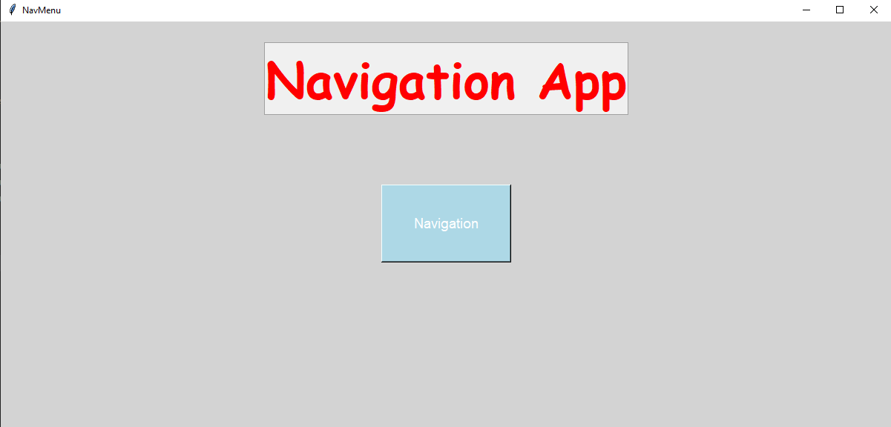

This test shows the main starting menu with a button that goes to the pre-navigation screen (where you select choices for navigation). For the higher-level objectives, this screen will be used to go to different choices.

Test 2:
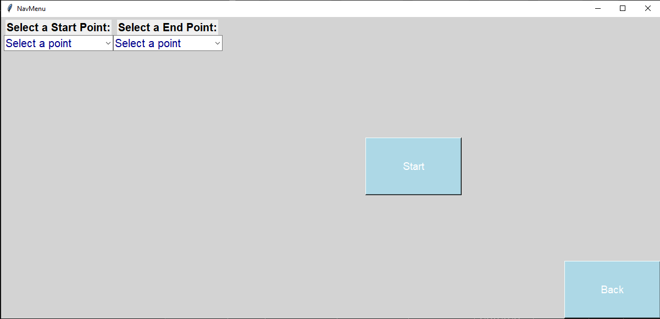

This test on the pre-navigation screen shows the dropdown boxes (both in the top left) a button to start navigation and a back button to go back to the previous screen (the main starting screen).

Test 3:
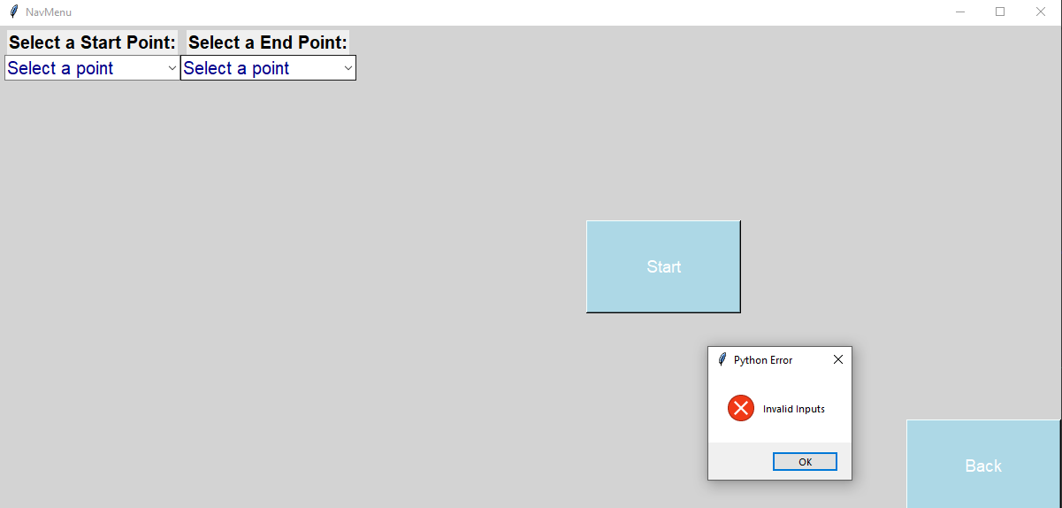

This test shows where neither a start points or an end point has been selected, such when the start button is used an error message is raised to the user, informing them that the inputs are invalid

Test 4:
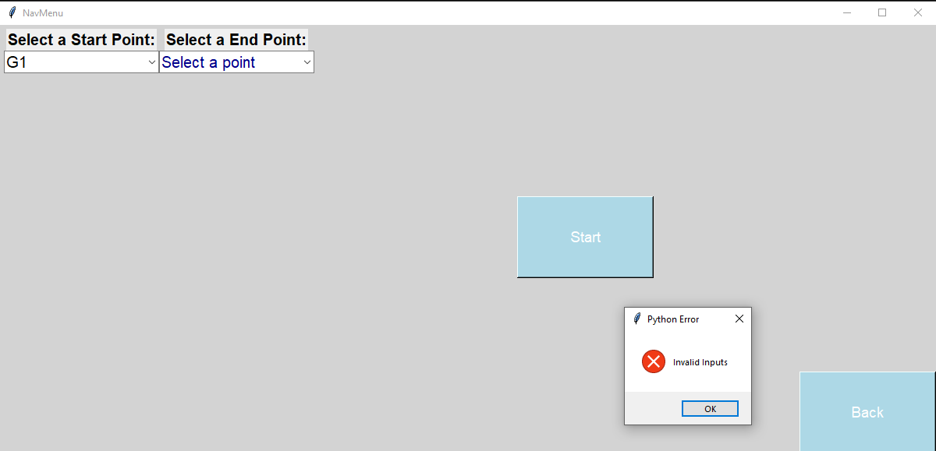

This test shows that a start point has been selected however no end point has been selected such when the start button is used an error message is raised to the user, informing them that the inputs are invalid.

Test 5:
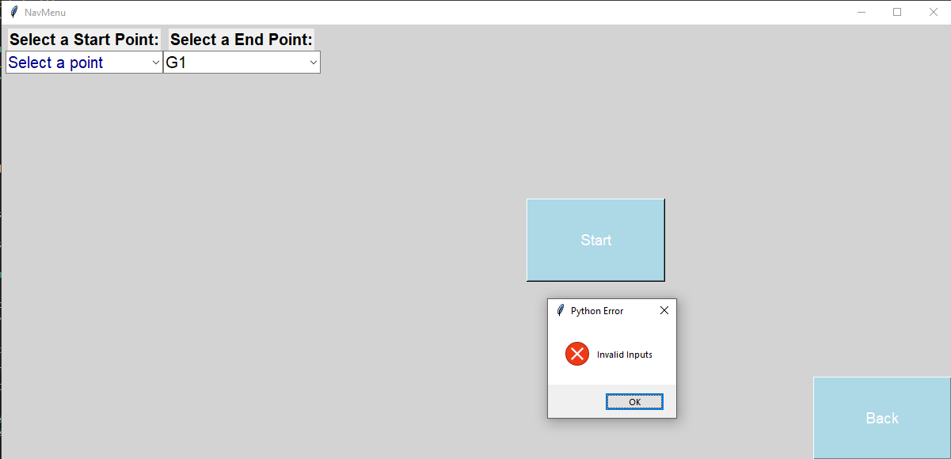

This test shows that an end point has been selected however no start point has been selected such when the start button is used an error message is raised to the user, informing them that the inputs are invalid.

Test 6:
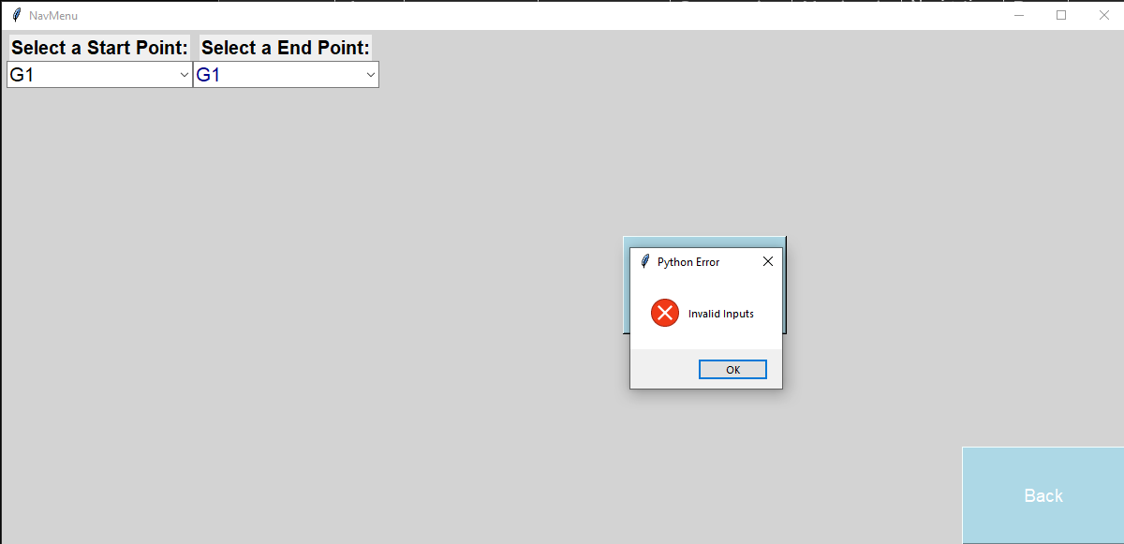

This test shows that a start point has been selected, and an end point has been selected however both the start point and end point are the same, such when the start button is used an error message is raised to the user, informing them that the inputs are invalid.

Test 8:
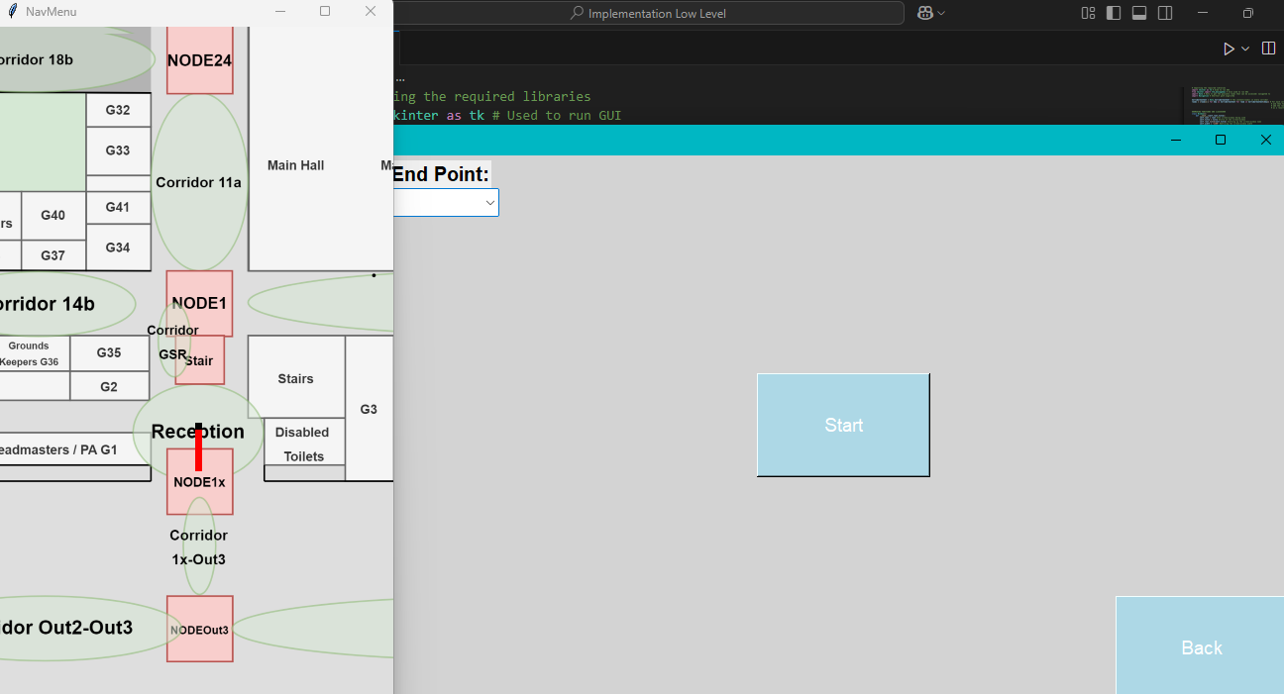

This test shows after entering valid inputs for the start and end point, the start button goes to the navigation menu (in this case it is also showing H1 of GUI)

Test 11:
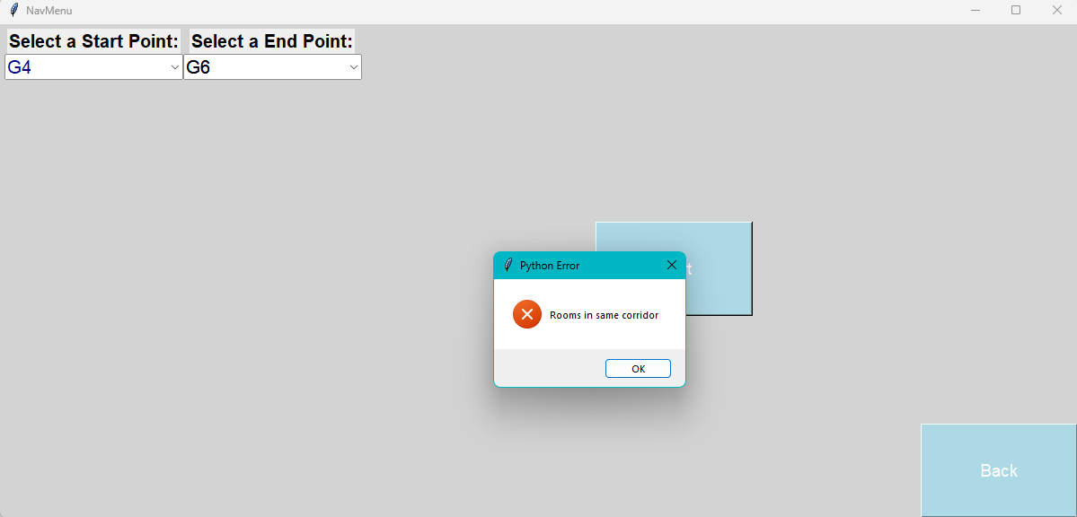

This test shows given two valid inputs, both of which are within the same corridor, the user is prompted with an error message telling them that the rooms are in the same corridor, hence navigation will not start.

Test 12:
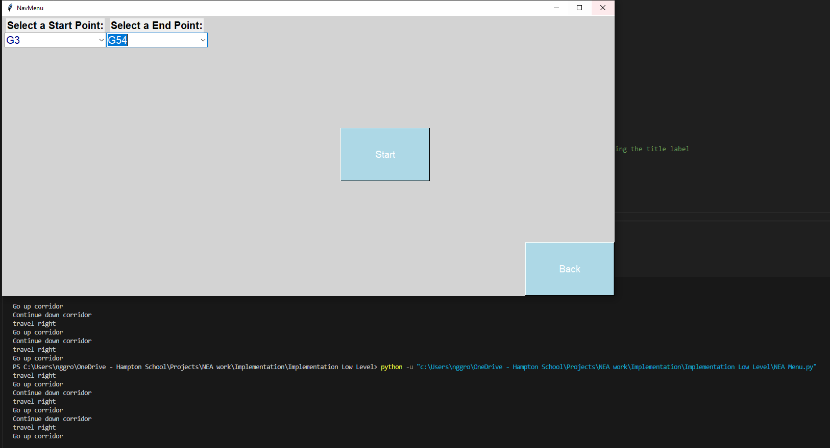

This test shows given valid inputs which are only on the ground floor, they correctly return a verbal description of the path taken (ignore red crossed part as this is result of a previous test).

Test 13:
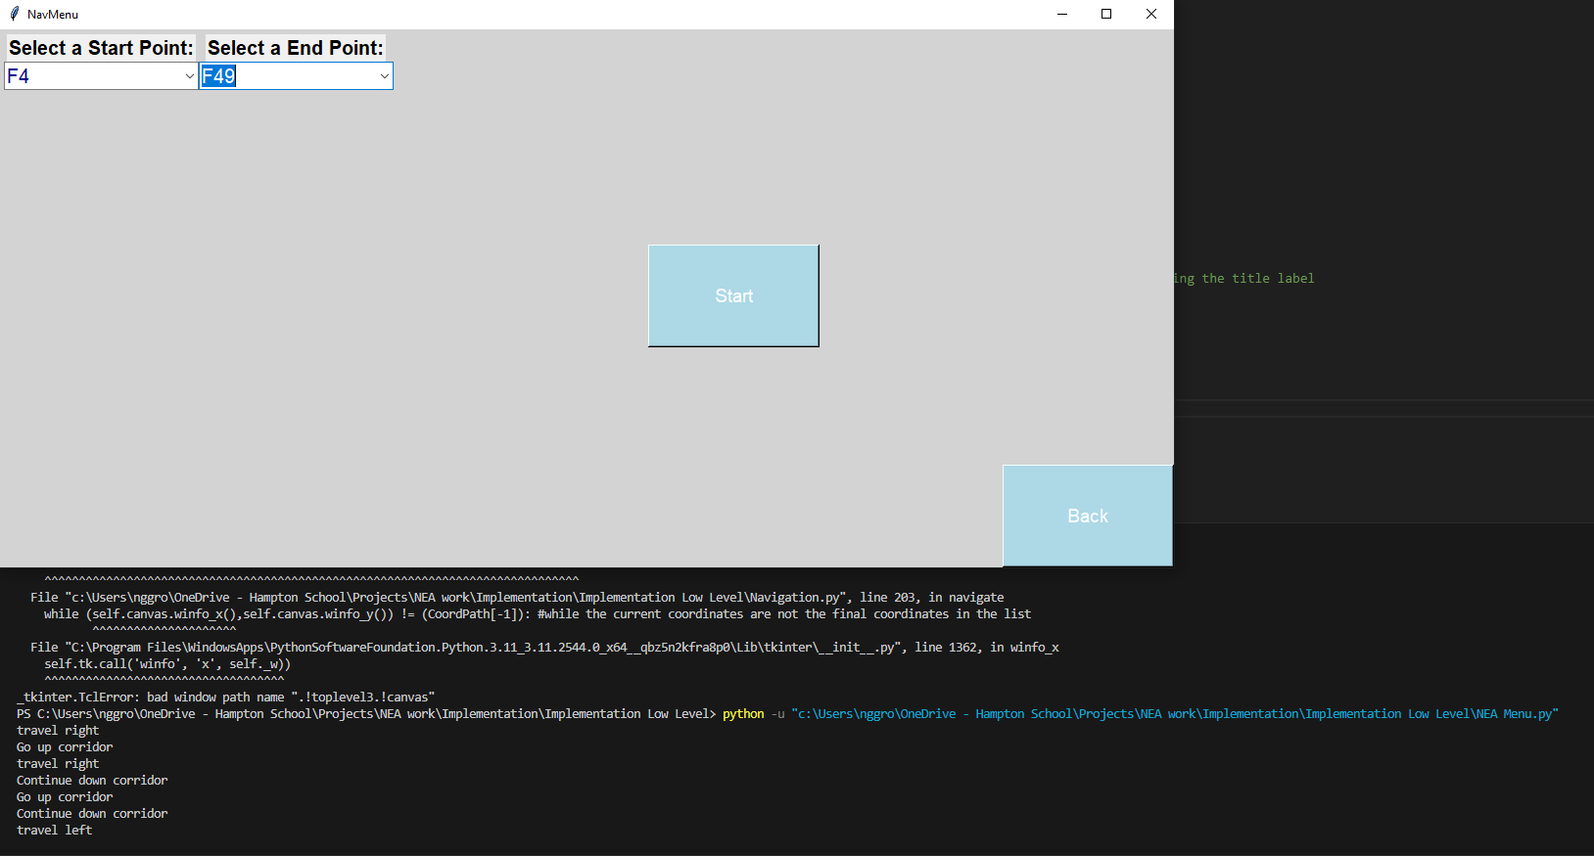

This test shows given valid inputs which are only on the first floor, they correctly return a verbal description of the path taken (ignore red crossed part as this is result of a previous test).

Test 14:
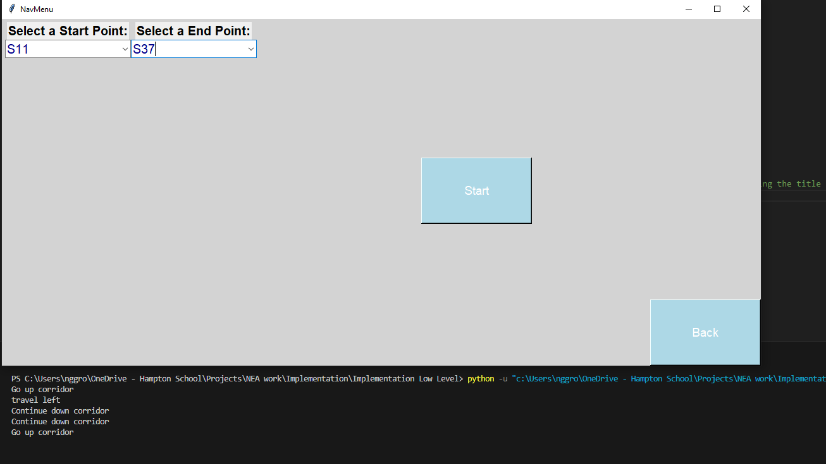

This test shows given valid inputs which are only on the second floor, they correctly return a verbal description of the path taken.

Test 15:
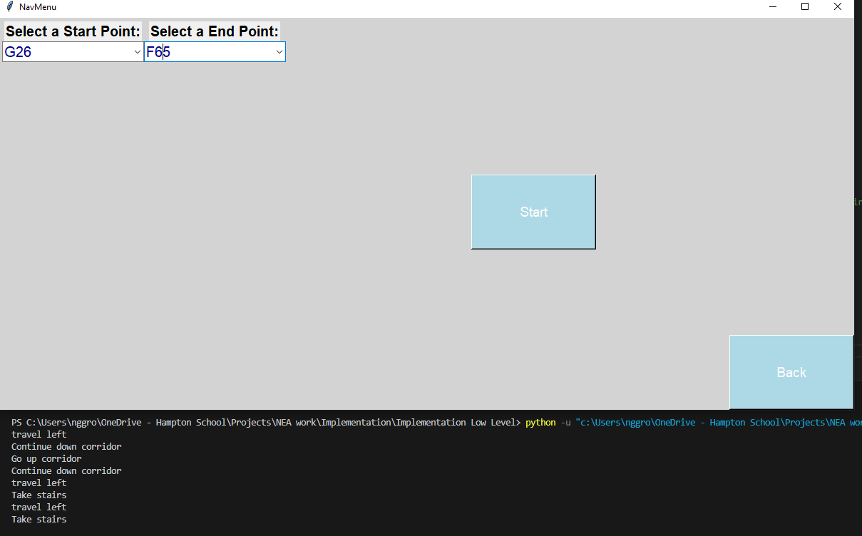

This test shows given valid inputs starting from the ground floor and ending on the first floor, they correctly return a verbal description of the path taken.

Test 16:
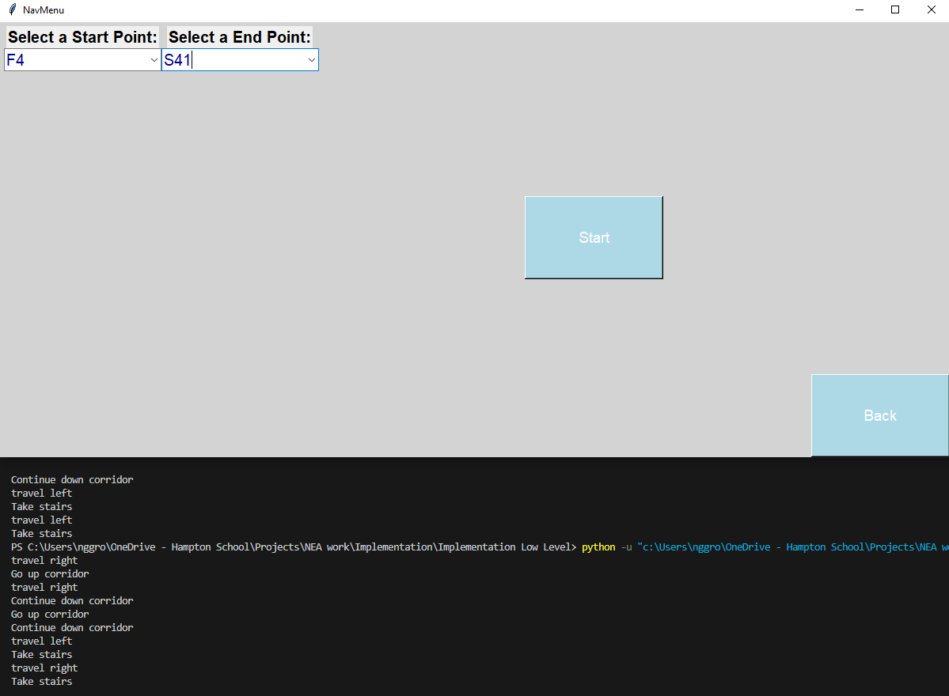

This test shows given valid inputs starting from the first floor and ending on the second floor, they correctly return a verbal description of the path taken.

Test 17:
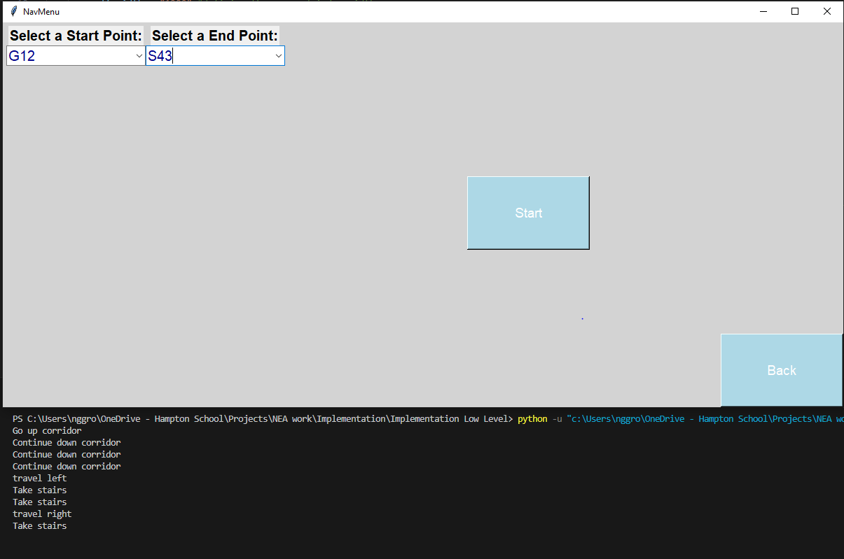

This test shows given valid inputs starting from the ground floor and ending on the second floor, they correctly return a verbal description of the path taken.

Test 31:
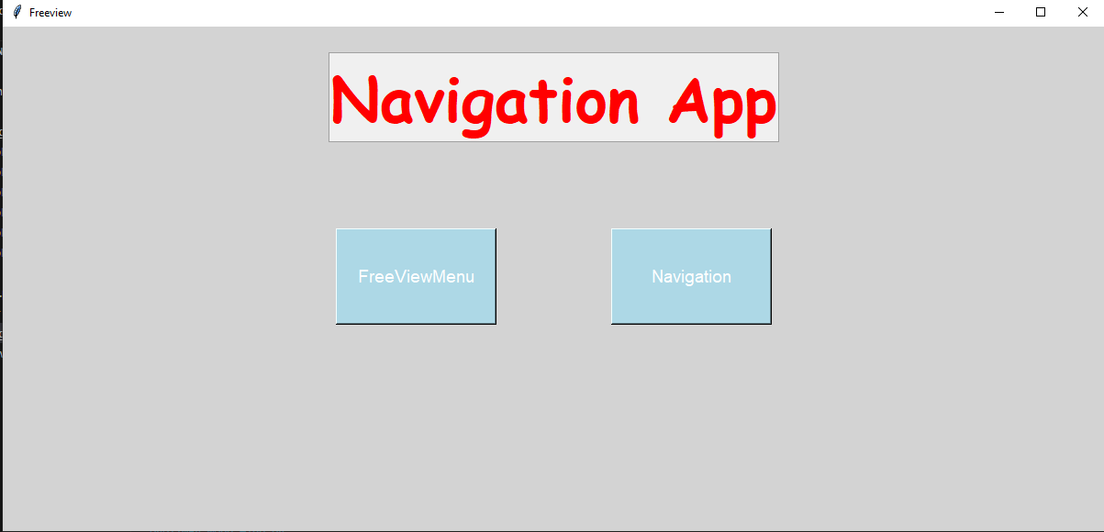

This test shows that now the menu on starting offers the user a choice between standard navigation and manual freeview navigation

Test 32:
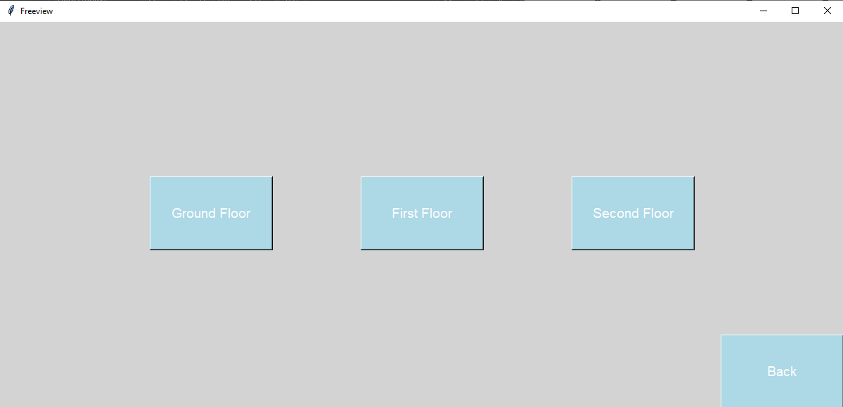

This test shows that the freeview navigation menu gives three options for navigation of each floor as well as a back button.
The remaining tests’ evidence are provided as video recorded tests separate to this document but will be submitted alongside.
The below shows which Tests correspond to which video (although it is mostly self-explanatory):
TestVideo19: Test 19, Test 7, Test 9, Test 10, Test 18
(Test 7,8,9,18 can all be confirmed by the navigation working so all the below tests can be evidence for these)
TestVideo20: Test 20
TestVideo21: Test 21
TestVideo22: Test 22
TestVideo23: Test 23
TestVideo24: Test 24
TestVideo25: Test 25
TestVideo26: Test 26
TestVideo27: Test 27
TestVideo28: Test 28
TestVideo29: Test 29
TestVideo30: Test 30
TestVideo33: Test33, Test34, Test35

Evaluation
The system as a whole works as intended and can provide a graphical interface for the user to navigate between rooms in the school, fulfilling the original main goal of the project.
Throughout testing, it proved to be consistent for all low-level test cases (and some high-level cases) whether navigation was between floors and within floors.
The content of the map was stored using a combination of different dictionaries and nested dictionaries, to come together to form a graph of nodes and distances in the form of an adjacency list that could be understood by Dijkstra’s algorithm.
There are several things that I haven’t included that in the future should I revisit this I should investigate adding:
Talk about the timetable navigation if not implemented xtx
Stepwise Navigation
The high-level objective (H2) for stepwise navigation to forward and backwards between steps was unfortunately not completed. Although set as a high-level objective as per requirements of the client did not prioritise it, this feature could have been quite useful. An option between the autonomous navigation and controlled step-by-step navigation could have been prompted as a choice, such accommodating for each who prefer each case.
Filtering the search for rooms for key words
The current dropdown box search allows you to either search the set of options or manually type in the rooms of interest if you know what rooms they are. A useful quality of life change that I could add would be to be able to filter key words such as departments, subject offices, head of year offices, stairs, toilets, etc… This would be further beneficial to the user as right now the system is designed to solve the problem of how a user navigates from one room to another, however this assumes that the user at least knows what room exactly they want to navigate to you. There are many users in reality who might not know exactly what room they want to go to but have a broader idea of the department they need to go to instead. A filter by these groups would be very useful for these types of users. As well as these specific types of users, the other groups such as toilets would be very useful to all users of the system. From my current system, it can return the shortest path to reach a specific destination but even more useful would be for the case of toilets to return the shortest path to the closest toilet from a start point. I would expect this feature to be particularly useful as it does not require the user to know where the closest toilet is but can instead return a specific result from a generic prompt.
Traffic Modelling
One variable that my program does not account for is the traffic at times during the day of the school. Certain paths of the school can become extremely congested, and as I have found from personal experience sometimes paths which are longer in distance are faster at certain times due to the extreme traffic on frequently used corridors. More advanced traffic models consider factors such as the flow rate and density of a path with respect to time and location of the path. For example, the Lighthill-Whitham-Richards Model (LWR Model) uses this idea and considers the function v(t,x) flow rate and p(t,x) density. It employs a law of conservation of mass for the number vehicles (in my case people) must be fulfilled. From a set of further complicated mathematics, a general first order differential equations can be produced, and with given inputs can model the traffic in a system quite well.
With much more time it would be interesting to look at this solution to realistically model the traffic on corridors and adjust it for my cases, however a much simpler application to produce somewhat similar results is to use a heuristic function that attaches an additional weighting to certain corridors with respect to time.
Intuitively, this function would be somewhat periodic with a period of ~40 minutes (as this is the length of periods at my school) such roughly every 40 minutes many students in the school start moving at once, and particularly and lessons just before morning break and lunch break all students will be moving at once. Such to achieve a function that is periodic I immediately consider a trigonometric function; in this case I will consider a sine graph.

I will then consider the general form of a sine graph such:
$$f\left(x\right)=a\sin^{b}\left(cx\right)$$
Where a, b, c are unknown real constants.
The sine function ranges from values from -1<f(x)<1 however I do not want my function to return a negative value, as there’s no situation in which traffic could somehow reduce the weighting on any corridor, such by inspection the b coefficient must be positive and even (as an odd value would still produce a range including negative values).
I will just for convenience let b = 2, to achieve a period of 45 (to account for time for students to get out of lessons and start congesting corridors), my function must reach 0 every 45 minutes, hence by setting my function to equal 0
$$f\left(x\right)=0$$
$${asin}^{2}{(cx)}=0$$
$$\sin\left(cx\right)=0$$
$$cx=\arcsin\left(0\right)$$
$$cx=0,π,2π,3π,…,nπ$$
$$x=0,\frac{π}{c},\frac{2π}{c},\frac{3π}{c},…,\frac{nπ}{c}$$
If I want the period to be 45 minutes, then the difference between 0 points is 45 minutes. From observation, the above series up to n is arithmetic with $d=\frac{π}{c}$ such:
$$45=\frac{π}{c}$$
$$c=\frac{π}{45}$$
Such I now have my desired coefficient for c.
Finally, the coefficient for a can be chosen as desired as this doesn’t do anything except control the amplitude or peaks of the sine graph. I will just choose a = 1 for simplicity.
Such I am left with the function:
$$f\left(x\right)=\sin^{2}{(\frac{πx}{45})}$$
This looks like the following below: 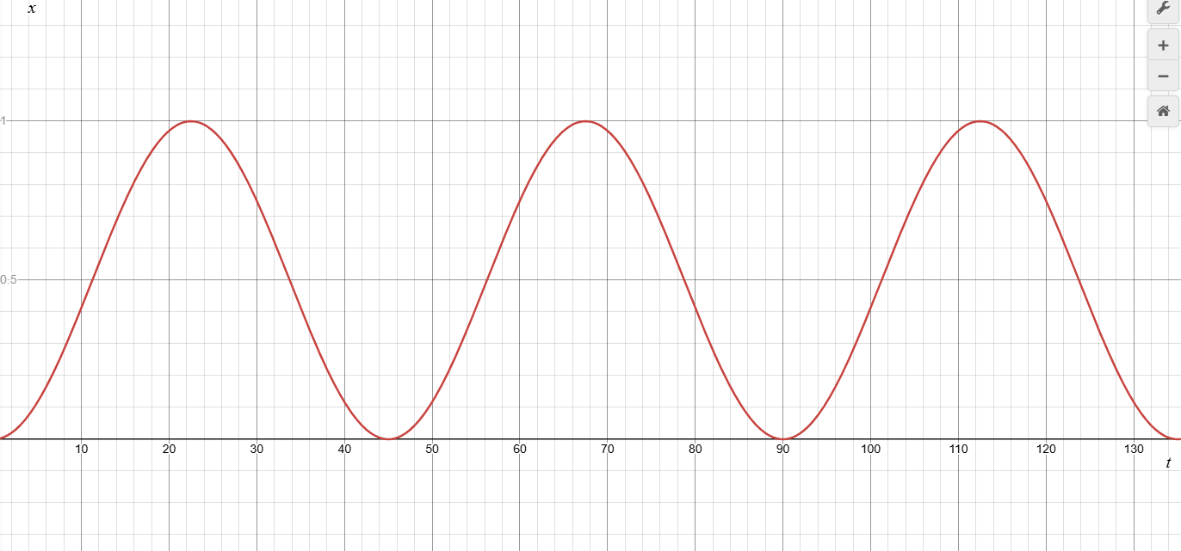
With a period of 45 minutes and amplitude of 1.
However, this function (although could model very simple traffic) does ignore many variables. The advantage of this model is that it is very simple to code in and easy to understand as it peaks traffic at ends of lessons and either side decreases traffic either side as students move into their lessons. This is not perfectly realistic by itself and this could be improved at least for the first period somewhat easily by considering two other functions to add on to this function.
Realistically, at the start of the day students enter the school in roughly two chunks, those who arrive early to school for whatever reason whether it is their normal schedule or for some before school club, and those who arrive in time for registration, such not too late and not too early. Such ideally, I would need the first peak to split into 2 different peaks of increasing amplitude (as I am assuming that more students arrive on time then early which is fair). One of my functions must be able to counteract the current graph so some sort of negative form of the original, and the other function must act between 0 and 45 minutes (the first period) and after this does not act at all.
Once again by intuition I consider the two functions g(x) and h(x). g(x) will be my counter function to reduce the peaks, and h(x) will be the multiplier to which this will act for (between 0 and 45)
h(x) will have to be some function that tends to zero for some value (as I need it to act within a specific domain and outside that do not act at all). This graph hence would be the positive exponential function that tends to 0 as the argument tends to negative infinity. As I want this to instead to tend to 0 for positive values, I need to take the negative form of the inputs, such
$$h\left(x\right)=e^{-ax}$$

Which looks like:
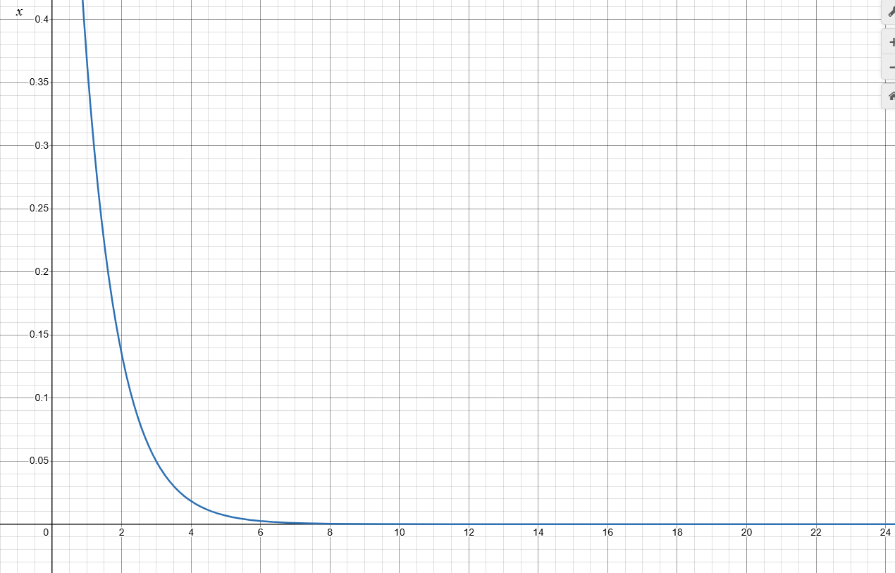
However I need this function to produce two peaks, such the graph will require a stationary point, or a peak. An easy way to this is add an x to the function such:
$$h\left(x\right)=xe^{-ax}$$
Which looks like:
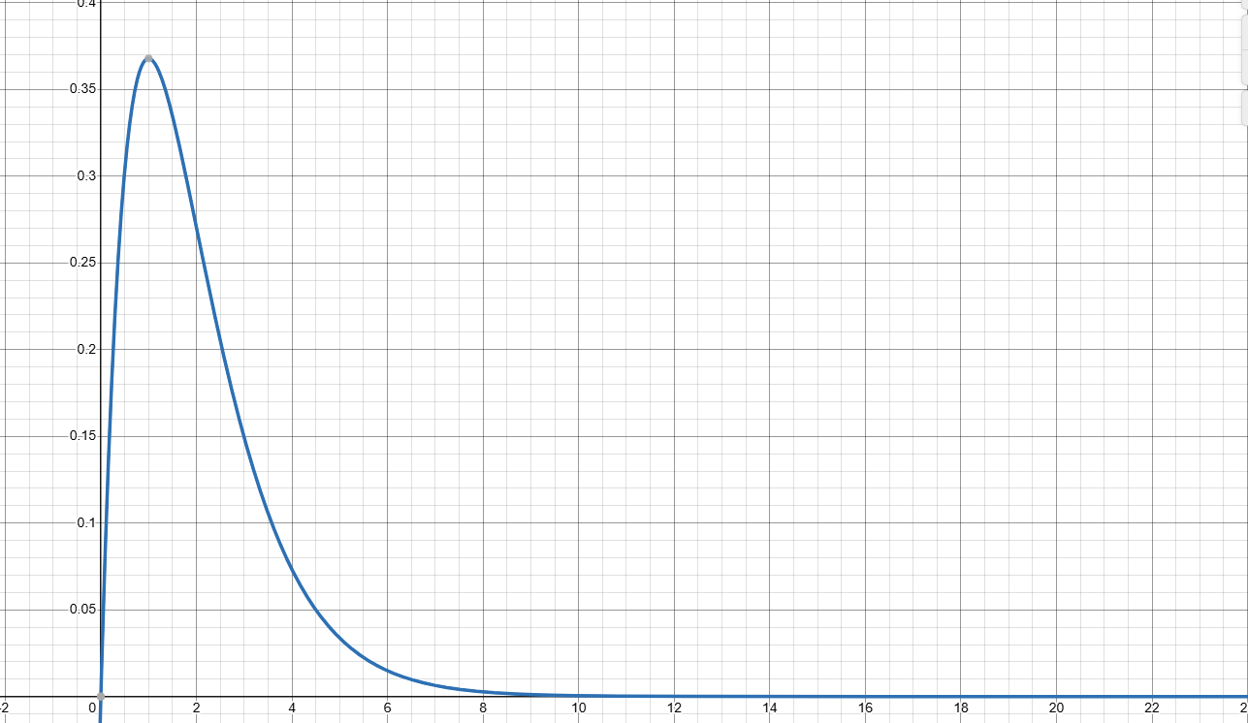
After some trial and error with values to optimally space the coefficients of h(x) along with g(x), I can produce a final composite function of the form:
$$f\left(x\right)+g\left(x\right)h\left(x\right)$$
Which with correct parameters looks like:
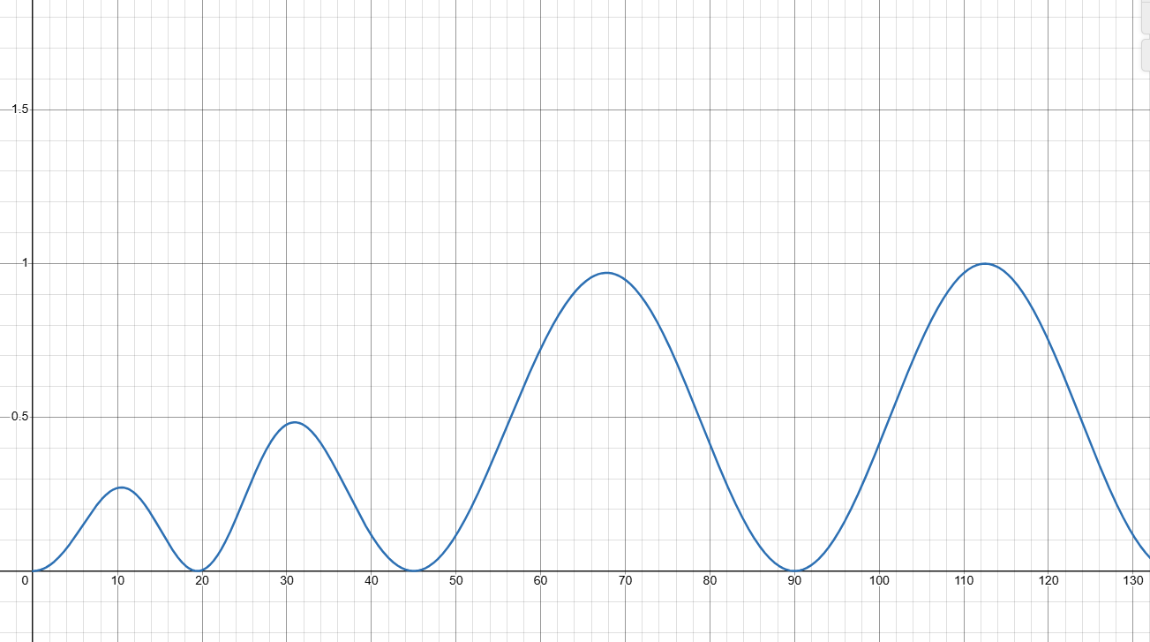
The first peak corresponds to the first wave of students who arrive early, the next wave of students being the rest of the students who arrive on time for registration.
By applying these weighted heuristic functions to my graph, it could potentially better navigate the school specifically for times in which congestion in the corridors can get quite severe.

A Gamified version of the navigation
A final idea that I had considered at the beginning of the project but decided would be too much for the time frame (and not specific to the current client) would be using the navigation and Dijkstra’s algorithm to create a small game to help users learn the school format. Where my solution is certainly a valid solution to those who do not know how to navigate the school, for users such as new students, they will need to properly familiarise themselves with the format of the school. In fact, just this navigation app could potentially hinder their learning process towards learning the school format if they become overly reliant on it and hence become harmful as opposed to useful. Such a fun and easy way to solve this problem would be creating a game based on this navigation system that helps learn the school format and provide a fun form of entertainment at the same time. The game could work as follows:
- User is given a start room and end room
- User must choose a path to get from the start room to the end room
- The algorithm finds the shortest path from the start room to the end room
- The distance between the most optimal path and the user path is compared and a corresponding score is returned
This way learning the school format can be made fun and competitive and allows the full building format to be familiarised rather than just certain parts of the school that a student may frequent more often.

Timetable Login/Register System
A login system that included encryption of the user’s data stored in a database was something that I developed for this project as part of the higher-level objectives, however as it was not fully functional along with the timetabling system, I have left it out of the implementation and so am discussing it here instead.
The idea behind this system would be for users (mainly directed towards students) would be able to login and auto navigate to their rooms based on their timetable and what period they are in during the day. This is mostly a quality-of-life change but adds much complexity to the program and could also allow for the development of other features such as storing navigation data into the database, so a recommended path navigation could be suggested based on recent navigation data.

